WORK ORDERS MODULE

SECTION 1 — WORK ORDERS LIST (W.O DASHBOARD)

This is the main screen for viewing and managing all Work Orders for a selected vessel.

1.1 Purpose
- Show all Work Orders (planned + unplanned) for the vessel.
- Allow users to filter by status, period, rank, component, and criticality.
- Provide entry points to:
  - View a Work Order
  - Edit / complete Part B
  - (Where permitted) postpone a Work Order
  - Create new Planned / Unplanned WOs

1.2 Top Filters & Controls

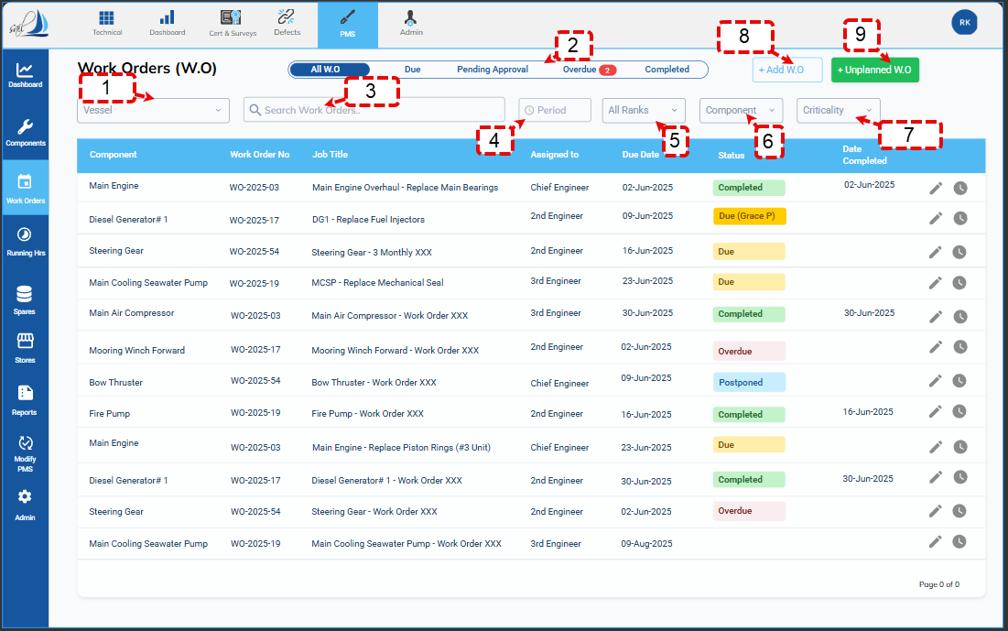
- Vessel Dropdown
  - Same vessel selector as other PMS modules.
  - Changing vessel reloads:
    - Work Order list
    - Filter values (components, ranks, etc.) for that vessel.
- Status Tabs (Segmented Control)
  - All W.O – shows all WOs for selected vessel.
  - Due – WOs whose status is “Due” or “Due (Grace P)”.
  - Pending Approval – WOs submitted by ship but not yet approved by HoD/office.
  - Overdue – WOs where current date or running hours have gone beyond allowed limit.
  - Completed – WOs with final approved status.
  - “Overdue” tab shows a red badge counter with the number of overdue WOs.
- Search Work Orders (free text)
  - Searches by:
    - Work Order No
    - Job Title
    - Component Name
    - Assigned Rank
  - Smart search, not case-sensitive.
- Period Filter
  - Predefined ranges (e.g., This Week, This Month, Next 30 Days, Custom Date Range).
  - Filters based on Due Date.
- All Ranks Filter
  - Dropdown showing ship ranks fetched from external crew/HR module.
  - Filters by Assigned To rank.
- Component Filter
  - Dropdown listing components (same as Components module).
  - Filters by Component field of WO.
- Criticality Filter
  - Options:
    - All
    - Critical Only
  - Uses component critical flag from Components module.
- + Add W.O Button
  - Creates a new Planned Work Order:
    - For office/manual creation (e.g., backdating or special planned job).
    - Opens Planned WO Form – Part A & B with fields editable as per role.
  - Will reuse same form but not auto-linked to a job unless user selects/link a job.
- + Unplanned W.O Button
  - Creates a new Unplanned Work Order (breakdown / defect).
  - Opens Unplanned WO Form with:
    - Blank Job Title, Component selectable, Maintenance Type = Unplanned.
(Later we will wire this with “Create WO Now” button in Components → Jobs section; those WOs will also appear here.)

1.3 Work Orders Table
Columns (left to right, matching screenshot):
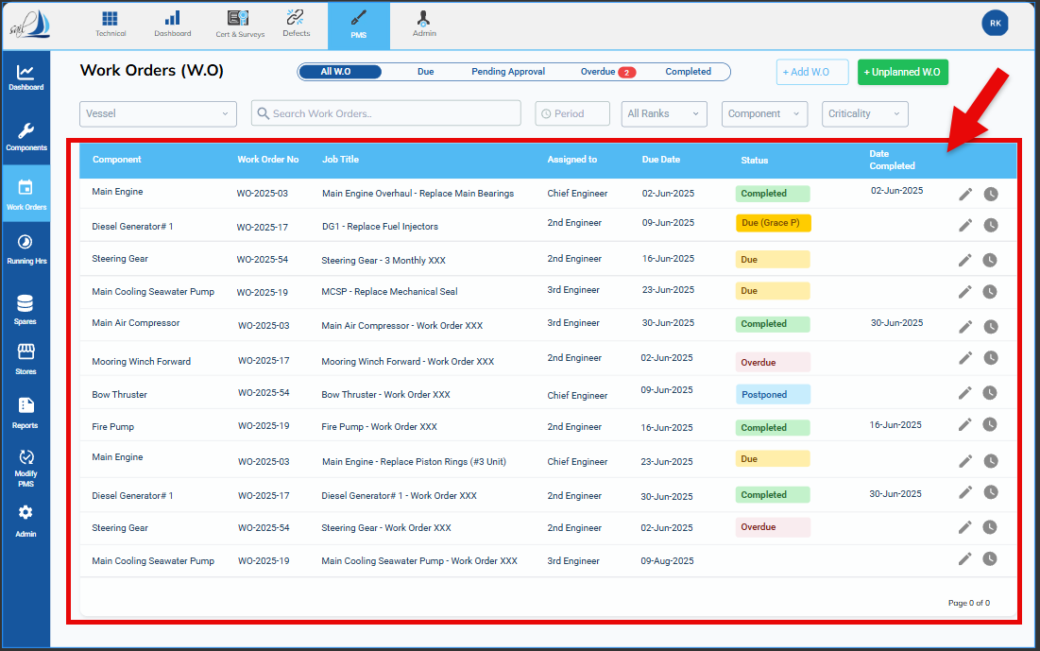
- Component
  - Component Name (e.g., “Main Engine”, “Diesel Generator #1”).
  - Optional: hover shows Component Code.
- Work Order No
  - Format for planned WOs (auto-created from job):
JOBCODE.WO-YYYY-XX
Example: J0B-331.831-02.WO-2025-01
(Job code + “WO-” + year + running number).
  - Unplanned WOs follow separate sequence: UWO-YYYY-XX (final format we can define in WO section).
- Job Title
  - From Job template (for planned) or entered by user (for unplanned).
- Assigned To
  - Rank for whom the WO is assigned.
  - Ranks list comes from external ship master-data module.
- Due Date
  - For calendar jobs: calculated due date (including postponements).
  - For RH jobs: projected due date or “—” if not calculated; list still sorts by internal due logic.
- Status
  - Possible statuses:
    - Due – WO generated within lead time but before due date.
    - Due (Grace P) – Due date exceeded but still inside grace period.
    - Overdue – Beyond due date + grace period OR beyond RH threshold + 168h grace.
    - Pending Approval – Part B filled by ship, waiting for HoD approval.
    - Postponed – WO postponed to a new date; next due still in future.
    - Completed – WO approved by HoD (final).
  - Colors (for UI guidance):
    - Completed → Green pill
    - Due → Orange pill
    - Due (Grace P) → Amber/Yellow pill
    - Overdue → Red pill
    - Postponed → Blue pill
    - Pending Approval → e.g., grey/blue pill
- Date Completed
  - Blank until WO is approved.
  - On approval: set to approval date.
- Row Actions (icons, right side)
  - Edit / Fill Form (pencil icon)
    - Opens WO Form.
    - Ship can fill Part B if WO is in “Due / Due (Grace P) / Overdue / Postponed” and not approved.
    - Office/HoD can open for approval.
  - View (eye icon)
    - Opens read-only WO Form (both Part A & B).
    - Used for Completed or locked records.
  - Postpone (may be a third icon or action within Edit screen; exact UI flexible)
    - Opens Postpone WO Modal for users allowed to postpone (HoD roles).

1.4 Status & Lifecycle Logic (at List Level)
- Generation
  - Planned WOs are auto-created from Jobs when:
    - Date / RH reaches Due – Lead Time threshold.
  - On-demand WOs created from Components → Jobs also appear here instantly.
  - Unplanned WOs created from + Unplanned W.O appear here once saved.
- Due vs Grace P vs Overdue
  - Due:
    - Current date < Due Date, AND
    - Within lead time window.
  - Due (Grace P):
    - Current date > Due Date BUT within Grace Period settings defined in Admin:
      - For calendar jobs:
        - If due before end of month → grace till end of that Amonth,
        - If due in last week of month → 7 days grace.
      - For RH jobs:
        - Grace = 168 running hours beyond due RH.
  - Overdue:
    - Goes beyond both Due Date and Grace Period.
    - Still counted as “outstanding” for dashboard and reporting.
- Postponed
  - When postponed via Postpone modal:
    - New Next Due Date is set.
    - Status becomes Postponed.
    - WO is not marked Completed.
    - A record is added in Maintenance History for that job:
      - “Postponed” with reason, authorized by, old due date, new due date.
    - WO will re-enter Due / Due (Grace P) states automatically when new date reaches lead time and due date.
- Completed
  - When Part B is filled and HoD approves:
    - Status becomes Completed.
    - Date Completed set.
    - Part A and Part B become immutable.
    - Maintenance History entry is created for that job.
    - Jobs table (Section C in Components) updates Last Done & Next Due logic.

1.5 Permissions Summary (List Screen Only)
Action | Ship Users | Office / HoD / Superintendent | PMS Admin
View WO list & filters | ✔️ | ✔️ | ✔️
Open WO in edit mode (Part B) | ✔️ (if assigned / allowed) | ✔️ | ✔️
Open WO in view-only mode (Completed) | ✔️ | ✔️ | ✔️
Create Planned WO via + Add W.O | Usually ❌ (configurable; default No) | ✔️ | ✔️
Create Unplanned WO via + Unplanned | ✔️ | ✔️ | ✔️
Postpone WO (open postpone modal) | ❌ (unless explicitly allowed) | ✔️ (HoD roles) | ✔️
Change filters / search | ✔️ | ✔️ | ✔️
(Fine-grained role mapping can be detailed later in Admin module, but this is the default logic.)
Perfect, sticking with Option 2 and keeping your existing section numbering intact.
Below is a drop-in block for your document:
1.6 DETAILED UI LAYOUT (ALL WORK ORDER SCREENS)
You can paste this under Section 1 (after 1.5) without touching any other section numbers.

1.6 Detailed UI Layout (All Work Order Screens)

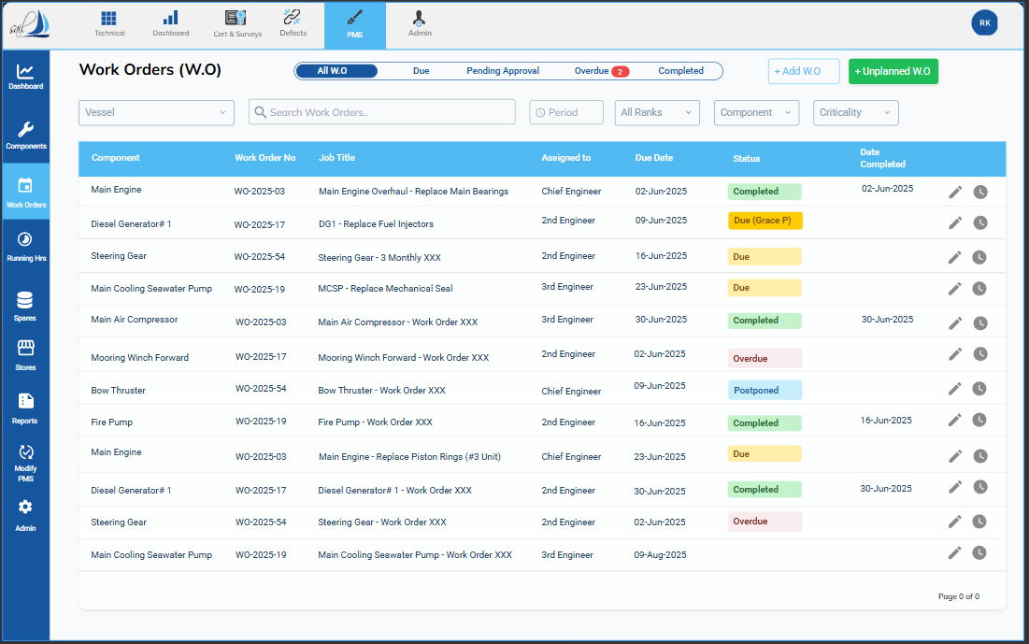
This section describes the visual layout and interactive elements of all Work Order–related screens in PMS.
It is the master reference for UI designers and frontend developers; logic and backend behavior are described in later sections.
Sub-sections:
- 1.6.1 Work Orders List (Dashboard)
- 1.6.2 Planned Work Order Form – Part A (Work Order Details)
- 1.6.3 Planned Work Order Form – Part B (Work Completion Record)
- 1.6.4 Unplanned Work Order Form (A + B Combined)
- 1.6.5 Work Instructions Modal
- 1.6.6 Postpone Work Order Modal
- 1.6.7 Inline Work History Block (inside Part A)
- 1.6.8 Spare Consumption UI (Part B)
- 1.6.9 Running Hours UI (Part B and RH Module Link)

1.6.1 Work Orders List (Dashboard)
This is the main operational screen for Work Orders.

1.6.1.1 Overall Page Layout
- Left Sidebar: existing PMS vertical menu (Dashboard, Components, Work Orders, Running Hrs, Spares, etc.).
  - Work Orders icon highlighted when this module is active.
- Top Global Bar: Technical / Dashboard / Cert & Surveys / Defects / PMS / Admin (unchanged from other modules).
- Main Content Area:
  - Top: header + status tabs
  - Middle: filters row
  - Bottom: Work Orders table (paged / scrollable)
All subsequent UI descriptions refer to this main content area.

1.6.1.2 Header Row
Left side:
- Title text: “Work Orders (W.O)” – bold, slightly larger font.
- Optional sub-caption: View and manage all maintenance work orders for the selected vessel.
Right side:
- Vessel Dropdown
  - Label: Vessel
  - Control: single-select dropdown.
  - Contents: list of vessel codes/names (V001 – MV SEAFARER, etc.).
  - When selection changes:
    - All filters and table content reload for that vessel.
    - Status tab counts refresh.
- Primary Action Buttons (aligned to the right of vessel dropdown):
  - + Add W.O
    - Visible for office/superintendent roles (configurable).
    - Opens Planned Work Order Form in creation mode (Part A + Part B).
  - + Unplanned W.O
    - Visible to ship and office.
    - Opens Unplanned Work Order Form in creation mode.
Buttons use the standard PMS primary style (blue background, white text).

1.6.1.3 Status Tabs Row
Directly below the header row.
Tabs (segmented control):
- All W.O
- Due
- Pending Approval
- Overdue
- Completed
Behavior:
- Only one tab active at a time.
- Each tab shows a count badge, e.g. Overdue (2).
- When user clicks a tab:
  - Table is filtered by that status.
  - Active tab gets blue underline + bold text.
  - Vessel selection is preserved.
  - Other filters (Period, Rank, etc.) remain as they are.

1.6.1.4 Filter Bar
Horizontal row below the tabs.
Controls from left to right:
- Search Box
  - Full-width text box on left.
  - Placeholder: Search by WO No, Job Title, Component, Rank...
  - Supports free-text; triggers fuzzy search on keyup with slight debounce.
  - A small x icon on the right clears search text.
- Period Filter
  - Dropdown labelled in-control as Period.
  - Options:
    - Today
    - This Week
    - This Month
    - Next 7 Days
    - Next 30 Days
    - Custom Range... (opens date-range picker)
    - All
  - Applies primarily on Due Date.
- Assigned Rank Filter
  - Dropdown labelled: All Ranks.
  - List populated from vessel’s rank master (CE, 2/E, 3/E, 4/E, C/O, 2/O etc.).
  - Single selection; filters WOs by Assigned To.
- Component Filter
  - Dropdown labelled: Component.
  - Contains list of component names for the vessel.
  - Typing within dropdown filters list by component name or code.
  - Selecting a component filters WOs to that component_code.
- Criticality Filter
  - Small dropdown or toggle labelled: Criticality.
  - Options: All, Critical Only.
  - Uses component’s Critical = Yes/No flag.
- Clear Filters Link
  - Right-aligned link or ghost button: Clear Filters.
  - Resets Period, Rank, Component, Criticality and Search back to defaults.
  - Does not change vessel or active status tab.

1.6.1.5 Work Orders Table
Below filter bar: main table occupying the rest of the page.
Table header (column names):
- Component
- Work Order No
- Job Title
- Assigned To
- Due Date
- Status
- Date Completed
- Actions
Column behaviour:
- Component
  - Displays Component Name (e.g. Main Engine).
  - On hover: tooltip with Component Code / SFI.
  - Optional: small tag if component is Critical (e.g. red “Critical”).
- Work Order No
  - Displays full WO Number (planned or unplanned).
  - Clickable text; clicking opens the WO in default mode:
    - If status = Due / Grace / Overdue / Postponed → open editable Part B (if user has permission).
    - If status = Completed / Pending Approval → open read-only view.
- Job Title
  - Single line text of job title.
  - For unplanned WOs, this is free text entered by user.
- Assigned To
  - Shows rank (e.g. Chief Engineer, 2nd Engineer).
  - Optionally show abbreviation + full name on hover.
- Due Date
  - For calendar jobs: formatted DD-MMM-YYYY.
  - For RH jobs:
    - If a projected date is calculated, show DD-MMM-YYYY (RH-based).
    - If no projection → show — and rely on status colour.
- Status
  - Colour coded badge:
    - Green: Completed
    - Orange: Due
    - Yellow: Due (Grace P)
    - Red: Overdue
    - Blue: Postponed
    - Grey/Blue: Pending Approval
  - Text inside badge exactly matches system status strings.
- Date Completed
  - For Completed WOs: DD-MMM-YYYY.
  - Blank for all other statuses.
- Actions
  - Icon buttons aligned right in cell:
    - Edit/Open (pencil or form icon)
      - Same behaviour as clicking WO number.
    - Postpone (clock/calendar-shift icon)
      - Visible only to users allowed to postpone.
      - Disabled/hidden if status doesn’t allow postponement (e.g. Completed).
    - View (eye icon – optional if you keep row-click = open).
Row behaviour:
- Hover: slight background highlight.
- Optional: clicking anywhere on row (excluding icon area) opens WO in default mode.
- Table supports pagination or infinite scroll; page controls at bottom right.
Empty state:
If no records:
- Show centred message:
“No Work Orders found for the selected filters.”
- Show two buttons below:
  - Clear Filters
  - + Unplanned W.O (if user has permission)

1.6.2 Planned Work Order Form – Part A (Work Order Details)
This form is opened when:
- User opens a planned WO from the list, or
- System or office user creates a new planned WO.
For ship users, all Part A fields are read-only. For office, editable only before WO is “frozen”.

1.6.2.1 Form Header
Top bar inside main content:
- Left:
  - Title: Work Order Form
  - Subtitle: Part A – Work Order Details
  - Underline line: Basic details about the work order (read-only for ship).
- Right:
  - Status badge (same colour scheme as list).
  - Buttons:
    - Work Instructions (opens modal; full width text).
    - Save (office only, when editing).
    - Back (returns to WO list).

1.6.2.2 Section A1 – Work Order Information
Layout: 2–3 columns of label + value rows (grid style).
Fields (labels & content):
- Work Order – WO Number
- Job Title – job title text
- Component – component name (with code below in smaller text)
- Maintenance Type – e.g. Scheduled Maintenance
- Assigned To – Rank
- Approver – Rank
- Frequency or Running Hours Based – Frequency / Running Hours
- Frequency or Running Hours Value – e.g. 3 Months or 500 Hours
- Job Category – e.g. Mechanical
- Job Priority – Low/Medium/High
- Class Related – Yes/No
- Status – text or mini badge summary
- Brief Work Description – multi-line, read-only box with description text.
All fields appear as filled read-only form controls (text boxes with disabled state) to visually match editable forms but cannot be changed by ship.

1.6.2.3 Section A2 – Required Spare Parts (Planned)
Block title: A2. Required Spare Parts.
- Table under the heading.
- Columns:
  - Part No
  - Description
  - Quantity Required
  - ROB (live from Inventory)
  - Status – text badges: Available, Low Stock, Order Required, etc.
For ship:
- No Add/Edit/Delete controls.
- For office (before WO is frozen), optional + Add Spare Part button appears in top-right of table.

1.6.2.4 Section A3 – Required Tools & Equipment
Block title: A3. Required Tools & Equipment.
- Similar table layout:
  - Tool / Equipment
  - Quantity Required
  - Current ROB (optional)
  - Status
Read-only for ship.

1.6.2.5 Section A4 – Safety Requirements
Block title: A4. Safety Requirements.
Fields:
- PPE Requirements – tokenised chips inside read-only multi-select field (e.g. [Leather Gloves] [Goggles] [Safety Helmet]).
- Permit Requirements – tags like [Enclosed Space Entry Permit].
- Other Safety Requirements – multi-line read-only text.

1.6.3 Planned Work Order Form – Part B (Work Completion Record)
Part B sits below Part A on same page, or under a second tab labelled Part B – Work Completion Record. This is the primary input area for the ship.

1.6.3.1 Part B Header
- Subtitle: Part B – Work Completion Record
- Helper text under title:
“Enter work completion details here including risk assessment, checklists, comments and spare parts consumed.”

1.6.3.2 Section B1 – Risk Assessment, Checklists & Records
Layout: vertical list of items with Yes/No/NA and upload buttons.
Each row:
- Left: label
- Middle: radio group Yes / No / NA
- Right: Upload button, View icon (when file exists).
Rows:
- B1.1 Risk Assessment Completed / Reviewed
- B1.2 Safety Checklists Completed (As applicable)
- B1.3 Operational Forms Completed (As applicable)
Uploads are optional.

1.6.3.3 Section B2 – Details of Work Carried Out
Two main blocks: Work Duration and Description & Experience.
Block B2.1 – Work Duration & Allocation
Fields arranged in 2 columns:
- Start Date – date picker (dd-mm-yyyy)
- Start Time – time input
- Completion Date – date picker
- Completion Time – time input
- No of Persons in the team – numeric
- Total Time Taken (Hours) – numeric (manual or auto calc)
- Manhours – numeric (can be auto = team × hours)
- Assigned To – dropdown (prefilled rank)
- Performed By – dropdown (actual performing rank)
Block B2.2 – Work Description
- Work Carried Out – large multi-line textbox.
- Job Experience / Notes – second multi-line textbox.

1.6.3.4 Section B3 – Running Hours
Small block with two fields in one row:
- Previous Reading – read-only numeric (auto filled from system).
- Current Reading – editable numeric (ship input).
Hint text below:
“Current Reading will update component running hours and job cycle upon approval.”

1.6.3.5 Section B4 – Spare Parts Consumed
Title: B4. Spare Parts Consumed.
Table with:
- Part No
- Description
- Quantity Consumed
- Comments (if any)
Rows:
- Pre-filled rows (from required spares) with editable Quantity Consumed and Comments.
- User can change quantity to 0 if not used.
Buttons:
- + Add Spare Part – opens inline new row or pop-up to select spare:
  - Search by Part No/Description.
  - For completely new spare: option Add New Spare (will auto-generate spare code; details entered in small form).

1.6.3.6 Part B Bottom Action Bar
At very bottom of page:
- Left side: optional Save Draft (if you support drafts).
- Right side:
  - Secondary button: Cancel / Back.
  - Primary button: Submit for Approval.
After Submit for Approval:
- Validations run (dates, RH, mandatory fields).
- If OK:
  - Part B becomes read-only.
  - Status = Pending Approval.
  - WO appears in Pending Approval tab.

1.6.4 Unplanned Work Order Form (A + B Combined)
Unplanned WO uses similar layout but with shorter Part A and without job frequency.

1.6.4.1 Header
- Title: Unplanned Work Order Form
- Subtitle: Breakdown / corrective maintenance not linked to job template.
- Status badge on right.
- Buttons:
  - Save (while editing).
  - Back.

1.6.4.2 Unplanned Part A – Work Information
Fields arranged in 2-column form:
- Work Order – generated UWO number (read-only once created).
- Vessel – dropdown (preselected).
- Component – component dropdown (mandatory).
- Job Title – free-text.
- Maintenance Type – fixed value Unplanned.
- Job Category – dropdown (Mechanical/Electrical/etc.).
- Job Priority – dropdown (Low/Medium/High).
- Class Related – Yes/No.
- Brief Work Description – multiline textbox.
- Assigned To – dropdown (Rank).
- Approver – dropdown (Rank).
No frequency or last-done fields for now.

1.6.4.3 Unplanned Part B
Identical to Planned Part B (Sections 1.6.3.2 to 1.6.3.6), including RA, Work Duration, RH, and Spare Consumption.

1.6.5 Work Instructions Modal
Triggered by Work Instructions button on WO header.

1.6.5.1 Modal Shell
- Centered overlay with dimmed background.
- Title bar:
  - Left: Work Instructions
  - Right: close icon (X).

1.6.5.2 Body
- Info line at top:
“Add work instructions – Text or copy-paste from manuals.”
- Main content: large text area (entire width).
  - For office roles:
    - Rich text editor toolbar (bold, italic, bullets, numbered lists).
  - For ship roles:
    - Text area is read-only (no toolbar).

1.6.5.3 Footer Buttons
- Save (for office users only; disabled for ship).
- Close button (or Cancel).
Saved content is linked to that WO and shown read-only everywhere.

1.6.6 Postpone Work Order Modal
Opened via Postpone icon from list or from WO form.

1.6.6.1 Header
- Title: Postpone Work Order
- Close (X) icon.

1.6.6.2 Section 1 – Snapshot (Read-Only)
Fields stacked:
- Work Order ID – WO Number.
- Component – name.
- Job Title.
- Assigned To.
- Original Due Date.
- Inform Office – checkbox.
All text fields are read-only; only checkbox editable.

1.6.6.3 Section 2 – Postponement Details
Editable fields:
- Reason for Postponement – large mandatory textarea.
- Authorized By – dropdown list of ranks allowed for authorization (CE/Master/etc.).
- Approval Remarks (Optional) – small text box.
- Next Due Date – date picker (must be > original due date).
- Duration of Postponement – read-only numeric field showing X Days (auto-calculated).
- Attach Document (Optional) – file upload control (single file).

1.6.6.4 Footer
- Left: Cancel
- Right: primary Confirm Postpone.
On confirm:
- Modal closes.
- Status = Postponed.
- WO list updates.
- History entry created.
- Alert generated if Inform Office ticked.

1.6.7 Inline Work History Block (Inside WO Part A)
Sits as Section A5 – Work History at bottom of Part A.

1.6.7.1 Default (Collapsed)
- Shows block header: A5. Work History.
- Beneath header, show latest 2 entries in a narrow table.
Columns:
- Work Order No
- Assigned To
- Performed By
- Total Time (Hrs)
- Due Date
- Completion Date
- Status (badge)

1.6.7.2 Expanded View
- Clicking header or a View All History link expands to full height table within scrollable container.
- Same columns plus:
  - Additional View icon per row that opens that historical WO in read-only mode in new window/tab or overlay.
History is read-only.

1.6.8 Spare Consumption UI (Part B)
This clarifies any ambiguity in B4 behavior.

1.6.8.1 Table Row States
- Preloaded rows (from job template):
  - Part No + Description are read-only.
  - Quantity Consumed editable numeric.
  - Comments optional text.
- New rows (user-added):
  - Part No – searchable dropdown (spares master).
  - Description auto-fills after part selection; or editable for brand-new spare.
  - Quantity Consumed mandatory.
  - Comments optional.
  - Delete icon on far right to remove row before submit.

1.6.8.2 Behaviour Notes
- If Quantity Consumed = 0 and row is preloaded, row can remain or be auto-suppressed in backend; UI just accepts zero.
- Total number of rows not limited (scroll inside table).
- ROB is not manually editable here; user sees info only in Part A.

1.6.9 Running Hours UI (Part B & RH Link)

1.6.9.1 Previous vs Current Reading
Located in B3. Running Hours panel:
- Two inline text boxes:
  - Previous Reading (disabled).
  - Current Reading (editable).

1.6.9.2 Validation Feedback (UI-level only)
If user enters:
- Value less than previous → red validation message under field:
“Current Reading cannot be less than Previous Reading.”
- Value obviously abnormal (ΔRH > threshold) → yellow warning message:
“Running hours increase is unusually high. Please confirm before submitting.”
These are soft validations (only the first is blocking; second is warning).

SECTION 2 — PLANNED WORK ORDER FORM (PART A: WORK ORDER DETAILS)
(This form is opened when a Planned WO is auto-generated OR created manually by office OR created On-Demand from Components → Jobs section)
This section captures all job template–driven data for a planned maintenance task.
Part A is fully immutable for ship users.
Only office/PMS admin has limited ability to create or adjust Part A during WO creation, but once saved, Part A is locked forever.
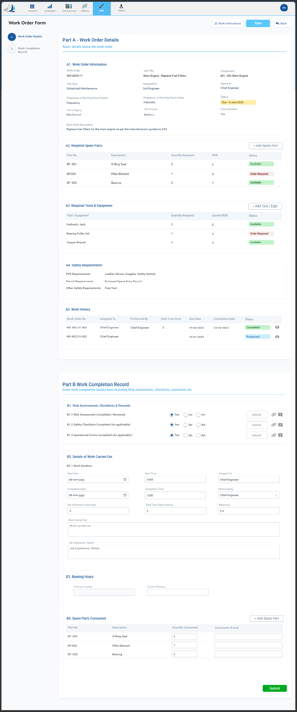

2.1 Purpose & Behavior
- Present all fixed job details taken from Jobs (Section C) such as:
  - Job Title
  - Component
  - Maintenance Type
  - Frequency / RH-based logic
  - Spare requirements
  - Tools & equipment
  - Safety requirements
- Allow assignment of rank (based on vessel’s crew rank master)
- Ensure WO cost, safety and job compliance are visible before execution.
- Part A cannot be edited after WO is created, except by office/PMS Admin before approval depending on permissions.
- Ship users never edit Part A, they only fill Part B.
2.1.1 Screen Header Layout
Top Row (inside the main content pane):
- Left Side:
  - Primary title: “Work Order Form” (bold, larger font)
  - Subtitle: “Part A – Work Order Details”
    - Smaller font
    - Light grey color
    - One-line description:
“Basic details about the work order (auto-generated from job template).”
- Right Side Buttons:
  - Work Instructions (small button, icon + text)
  - Save (only for office users before approval; hidden for ship)
  - Back (always visible)
Below header
A status badge appears aligned to the right (above the form), using standard PMS status colour scheme:
- Green – Completed
- Orange – Due
- Yellow – Grace P
- Red – Overdue
- Blue – Postponed
- Grey – Pending Approval

2.1.2 Page Structure
The entire Part A is divided into four visual blocks:
- A1 — Work Order Information
- A2 — Required Spare Parts
- A3 — Required Tools & Equipment
- A4 — Safety Requirements
- A5 — Work History
All blocks are collapsible with arrows. All blocks start expanded by default.
A light grey dividing line separates blocks.

2.1.3 A1 — WORK ORDER INFORMATION (UI Layout)
This is the primary summary panel.
Layout Structure:
- 3-column responsive grid
- Each item: Label (top) + Disabled input box (bottom)
- Disabled boxes keep form consistency
Fields (in order left → right, top → bottom):
- Work Order
  - Read-only text box showing WO Number.
  - Example: JOB-331.831-01.WO-2025-17
- Job Title
  - Pre-filled from Job Template.
  - Example: “Main Engine – Replace Fuel Filters”.
- Component
  - Dropdown-style read-only control.
  - Shows: 601.002 Main Engine.
- Maintenance Type
  - Value: Scheduled Maintenance (always fixed for planned).
- Assigned To
  - Rank (CE / 2E / 3E etc.).
- Approver
  - Rank (as assigned by office).
- Frequency or RH Based
  - Value: Frequency or Running Hours.
- Frequency / RH Value
  - E.g.: 3 Months or 500 Hours.
- Status
  - Read-only dropdown-like field.
- Job Category
  - Mechanical / Electrical / Hull / Deck.
- Job Priority
  - Low / Medium / High.
- Class Related
  - Yes / No.
- Brief Work Description
  - Large disabled multi-line textarea.
  - Scrollable if long.
UI Behaviour Notes:
- Everything in A1 is read-only for ship.
- For office, editable only for new WOs before saving.
- Field tooltips appear on hover with backend field names (for dev reference).

2.1.4 A2 — REQUIRED SPARE PARTS (UI LAYOUT)
Block title: “A2. Required Spare Parts”
Table Layout
Columns (left → right):
- Part No
- Description
- Quantity Required
- ROB (Real-time)
- Status Badge
Row Behaviour:
- All rows pre-populated from Job Template.
- Fields are non-editable in Part A.
- ROB is fetched dynamically from Inventory module.
- Status badges:
  - Green – Available
  - Red – Order Required
  - Yellow – Low Stock
Right-Side Controls:
- For office: + Add Spare Part button (small).
- For ship: hidden.

2.1.5 A3 — REQUIRED TOOLS & EQUIPMENT (UI LAYOUT)
Similar to A2.
Columns:
- Tool / Equipment
- Quantity Required
- Current ROB (optional)
- Status
Rows show tool requirements imported during Job Master creation.
All fields read-only for ship.

2.1.6 A4 — SAFETY REQUIREMENTS (UI LAYOUT)
A4 contains 3 form controls stacked vertically.
Fields:
- PPE Requirements
  - Shown as grey tags:
    - [Leather Gloves] [Goggles] [Safety Helmet]
- Permit Requirements
  - Tags:
    - [Enclosed Space Entry Permit]
- Other Safety Requirements
  - Multi-line disabled textarea.
No editing for ship.

2.1.7 A5 — WORK HISTORY (UI LAYOUT)
Shows latest 2 history entries, with expandable full view.
Collapsed View (default)
Table with columns:
- Work Order No
- Assigned To
- Performed By
- Total Time (Hrs)
- Due Date
- Completion Date
- Status
Expanded View
- Scrollable table with all historical entries
- “View” icon to open historical WO in read-only view.

2.1.8 Part A Footer
No footer buttons except:
- Top-right Back
- Office may have Save before WO is frozen.

2.2 When Part A Is Auto-Filled

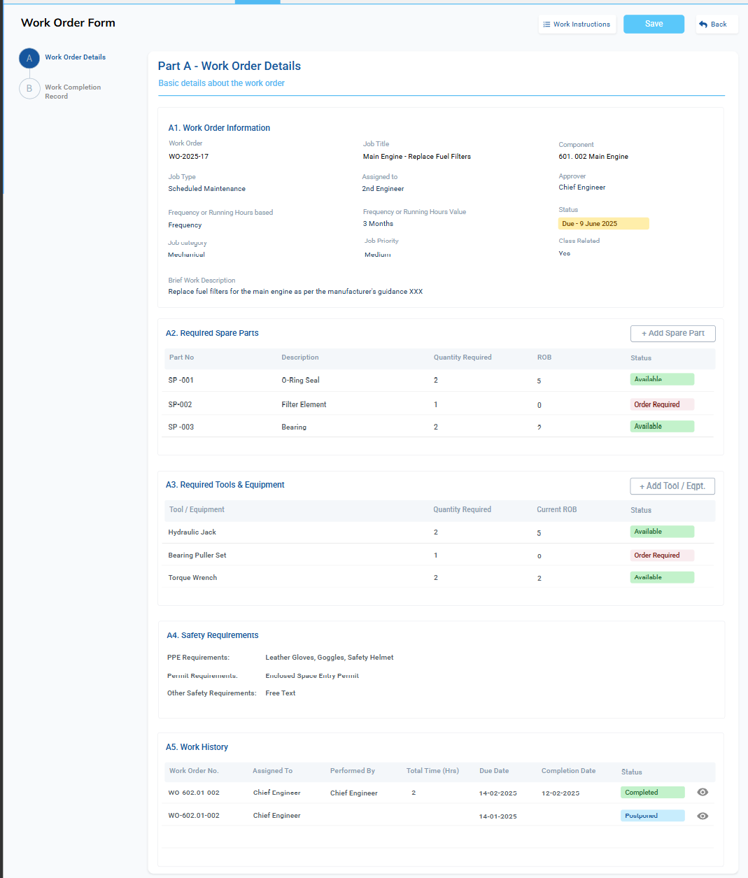
Part A is auto-filled under three cases:

1. Auto-generated Planned WO (from Jobs module)
Triggered by:
- Calendar frequency + lead time
- RH-based cycle + lead RH
The system copies job template details into Part A.

2. On-Demand Planned WO (from Components → Jobs → Create WO Now)
Triggered by user explicitly performing a job early or due to breakdown.
Part A is pre-filled based on the selected job.
Hidden internal flag:
- created_from_job = TRUE
- creation_mode = ON_DEMAND

3. Manual Planned WO (from + Add W.O button)
Used by office only (ship usually not allowed)
- Office selects component, selects job, or creates a planned WO referencing a job.

2.3 Part A — Field-by-Field Specification

A1. Work Order Information
Field | Description | Editable | Source
Work Order No | Auto-generated WO number | ❌ Locked | Based on jobcode.WO-YYYY-XX
Job Title | Name of maintenance | ❌ Locked | From job template
Component | Component associated with job | ❌ Locked | From job template
Maintenance Type | Scheduled Maintenance | ❌ Locked | From job template
Assigned To (Rank) | Person responsible | ✔️ Editable only by office before approval | Rank list from external master data
Approver | HoD rank who must approve | ✔️ Editable only by office | From vessel’s approval hierarchy
Frequency / RH Based | Mode of maintenance | ❌ Locked | From job template
Frequency / RH Value | e.g., 3 Months / 500 RH | ❌ Locked | From job template
Job Category | Mechanical / Electrical / Deck | ❌ Locked | From job template
Job Priority | Low / Medium / High | ❌ Locked | From job template
Class Related | Yes/No | ❌ Locked | From job template
Status | Due / Grace P / Overdue | ❌ Locked | System-calculated
Brief Work Description | Short task summary | ❌ Locked | From job template

WO Numbering Logic
For planned WOs:
<jobcode>.WO-<year>-<running-number>
Example:
JOB-331.831-01.WO-2025-01
Running number resets every year per job.

A2. Required Spare Parts
Spare parts pre-listed from job template.
Table columns:
- Part No
- Description
- Quantity Required
- ROB (real-time stock from Spares Module)
- Status (Available / Low Stock / Order Required)

Behavior
- Ship users cannot edit in Planned WO Part A.
- Office can add/remove spares only before WO approval.
- Spare ROB values update in real-time from Spares module.
- After completing Part B:
  - Part B will record quantity consumed → instantly deducted in Spares module.

A3. Required Tools & Equipment
Pre-defined list added when job was created.
Table columns:
- Tool / Equipment
- Quantity Required
- Current ROB
- Status
Behavior:
- Same as spares:
  - Ship cannot edit Part A
  - Office can adjust before approval
Source:
- Entered from maker manual during job creation.

A4. Safety Requirements
Includes PPE, permits, and other safety notes.
Fields:
- PPE Requirements: Tag input (from job template)
- Permit Requirements: Tag input (Enclosed Space Permit, Hot Work Permit, etc.)
- Other Safety Requirements: Free text
Behavior:
- All fields are locked for ship
- Editable only by office before initial WO approval

A5. Work History (Ref Only)
Shows the last two WO completions for this job.
Columns:
- Work Order No
- Assigned To
- Performed By
- Total Time (Hours)
- Due Date
- Completion Date
- Status
- View (to open previous WO in read-only mode)
Behavior:
- Shows 2 most recent records by default
- Expanding panel shows all historical records
- All records are immutable
Source:
- Stored in Maintenance History table per job

A6. Top Controls for Part A Screen
- Work Instructions
  - Opens modal for SOP text
  - Editable only by office before approval
  - Ship sees read-only
- Save (Office)
  - Saves Part A during manual creation
  - Auto-created WO usually doesn’t require Save on Part A
- Back
  - Returns to WO List

2.4 Part A Permissions Summary
Role | Can Create WO | Can Edit Part A | Can View Part A | Notes
Ship | Unplanned only + On-demand planned | ❌ Never | ✔️ Always | Ship only fills Part B
Office/HoD | Planned + Unplanned | ✔️ Before approval | ✔️ Always | Office decides assignment & approver
PMS Admin | All | ✔️ Full | ✔️ Full | For data correction or configuration

2.5 Part A Immutability Rules
- Once a WO is approved, Part A becomes permanently locked.
- Even PMS Admin cannot modify job details after approval.
- Ensures:
  - Legal defensibility
  - Class compliance
  - Maintenance traceability

2.6 Link With Components → Jobs (Section C)
When WO is created via “Create WO Now”:
- All fields in Part A are pulled from that job’s template.
- “Next Due Date” and “Last Done Date” in Components will update only after WO completion + approval.
- If existing auto-generated WO exists for the same job/cycle:
  - It becomes “Superseded” or removed based on admin rule (configured later).

SECTION 3 — PART B: WORK COMPLETION RECORD
(To be filled by ship after doing the job; approved by HoD; immutable afterwards)
Part B captures all details of the actual work performed, along with supporting documents and running hours.
This section is editable only before approval.
After approval → permanent record.
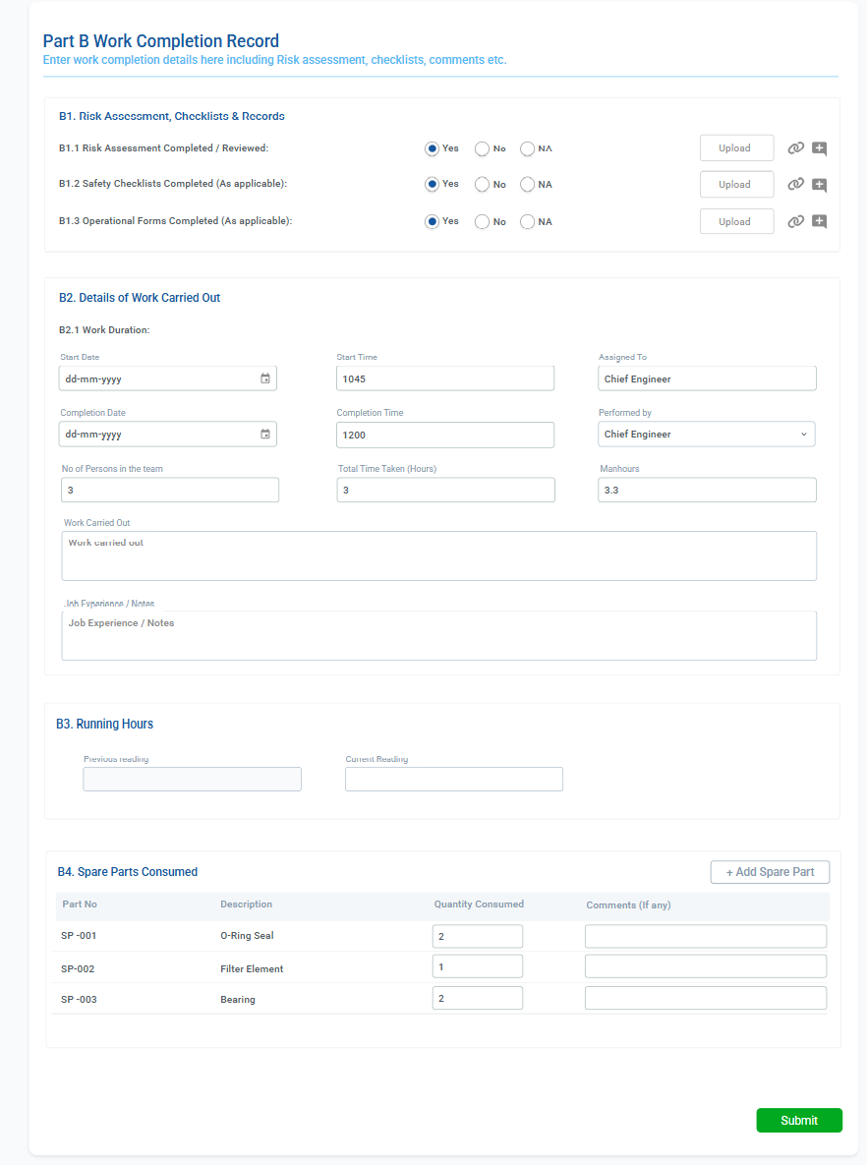

3.1 Purpose of Part B
- Record the actual execution of the maintenance work.
- Capture safety compliance (RA, checklists, permits).
- Record time taken, manpower, running hours.
- Log spare consumption.
- Generate immutable maintenance history once approved.
- Update Jobs → Last Done / Next Due logic.
- Deduct spares from inventory in real time.
- Provide an official, class-ready audit trail.
Part B is the ONLY section ship users actually fill.
3.1.1 Part B Header Layout
- Title: “Part B – Work Completion Record”
- Subtitle:
“Enter work completion details including risk assessment, checklists, manpower, running hours, and spare parts consumed.”
Buttons on right:
- Primary: Submit for Approval
- Secondary: Cancel / Back
- Optional: Save Draft (if draft system enabled)

3.1.2 B1 — Risk Assessment, Checklists & Records (UI Layout)
UI Structure
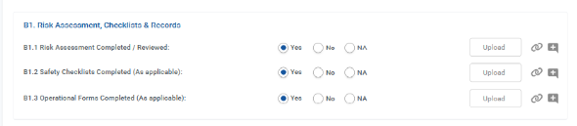
Each item is a row with:
- Left: label
- Center: Yes / No / NA radio buttons
- Right: Upload button, View icon (if file exists)
Rows:
- B1.1 Risk Assessment Completed / Reviewed
- B1.2 Safety Checklists Completed (As applicable)
- B1.3 Operational Forms Completed (As applicable)
Upload Interaction
- Upload opens file selector
- After upload:
  - Replace “Upload” with:
    - Uploaded ✔ text
    - View (eye icon)
    - Replace file (small icon)
- File formats allowed: PDF, DOCX, JPG.

3.1.3 B2 — Details of Work Carried Out (UI Layout)
Block B2.1 — Work Duration
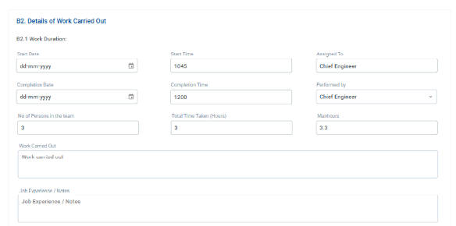
Two-column grid layout:
- Start Date (date picker)
- Start Time (text-time input)
- Completion Date
- Completion Time
- No. of Persons in Team (numeric)
- Total Time Taken (Hours) (auto or user-input)
- Manhours (auto = persons × hours)
- Assigned To (drop-down)
- Performed By (drop-down)
Validations:
- Completion Date ≥ Start Date
- If same day → Completion Time ≥ Start Time

Block B2.2 — Work Description
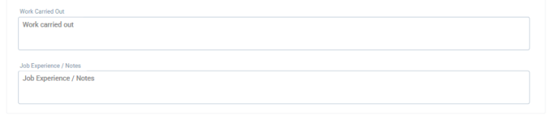
Two large text areas:
- Work Carried Out
- Job Experience / Notes
Both mandatory unless job category has exceptions.

3.1.4 B3 — Running Hours (UI Layout)
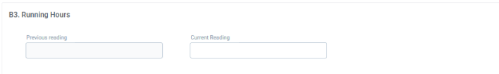
Small two-field block:
- Previous Reading (disabled)
- Current Reading (numeric input)
Validation:
- Must be ≥ previous
- If very high increase → yellow warning
Caption under fields:
“This will update component running hours once approved.”

3.1.5 B4 — Spare Parts Consumed (UI Layout)
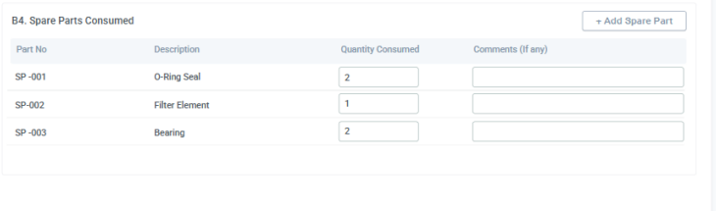
Table Columns:
- Part No
- Description
- Quantity Consumed (editable)
- Comments (optional text field)
Row Types:
1. Auto-loaded rows (from Part A)
- Part No, Description → read-only
- Quantity Consumed → editable
- Comments → editable
- User may set Quantity = 0 if not used
2. User-Added Rows
User clicks:
- + Add Spare Part
Popup or inline row with:
- Part No — searchable dropdown
  - Search by Part No / Description / Maker
- Description — auto-filled or editable
- Quantity Consumed — number
- Comments
- A delete icon at right for removing row

3.1.6 Part B Footer Buttons
Right side:
- Submit for Approval
  - Mandatory fields validated
  - Moves status → Pending Approval
  - Makes B read-only
Left side:
- Save Draft (if enabled)
- Cancel / Back

3.2 Layout Overview
Part B contains four subsections:
- B1. Risk Assessment, Checklists & Records
- B2. Details of Work Carried Out
- B3. Running Hours
- B4. Spare Parts Consumed
Finally → Submit (for approval) button.

3.3 B1 — Risk Assessment, Checklists & Records
This section verifies if safety documentation was completed during the job.
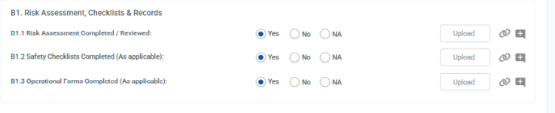

Rows (as per your UI)
Field | Inputs | Buttons
B1.1 Risk Assessment Completed / Reviewed | Yes / No / NA | Upload, View
B1.2 Safety Checklists Completed | Yes / No / NA | Upload, View
B1.3 Operational Forms Completed | Yes / No / NA | Upload, View

Logic
- Upload is NOT mandatory even if “Yes” is selected.
- If file uploaded:
  - Stored in PMS file store.
  - Viewable by ship/office/company.
- Ship cannot delete files after saving Part B (unless configured by company).
- Office can view all files before approval.

After approval
- Files become read-only.
- Entire B1 section locked.

3.4 B2 — Details of Work Carried Out
The main work execution fields.

B2.1 Work Duration
Fields:
- Start Date (calendar input)
- Start Time (HHMM)
- Completion Date
- Completion Time
- No. of Persons in Team
- Total Time Taken (Hours)
  - Can be auto-calculated or manually entered (your call later).
- Manhours
  - (No. of persons × Total time taken)
  - Can be auto or manual.
- Assigned To (rank)
- Performed By (rank)

Rules
- Ship enters all fields.
- HoD reviews before approval.
- No edits after approval.

B2.2 Work Carried Out (Description)
Free text field.
Ship describes:
- What was done
- Findings
- Steps completed
- Abnormalities found
- Any replacements
- Any deviations
This text becomes part of maintenance history.

B2.3 Job Experience / Notes
Additional comments:
- Observations
- Lessons learned
- Safety concerns
- Condition monitoring notes
Stored in maintenance history.

3.5 B3 — Running Hours
Purpose:
- Update running hours after job execution.
- Update parent/child RH calculations.
Fields:
- Previous Reading (pre-filled, read-only)
- Current Reading (entered by user)

Logic (As per your clarification):
- Previous Reading = last stored RH for the parent component.
- User enters Current Reading after doing the job.
- After approval:
  - Component’s RH is updated to Current RH.
  - Δ RH = Current – Previous
  - Δ RH is added to all child components (except replaced items which follow separate logic handled in Components Module).
For RH-based jobs:
- The system uses B3 to:
  - Update Last Done RH
  - Recalculate Next Due RH threshold
For calendar jobs:
- B3 is just record-keeping.
After approval → B3 is locked.

3.6 B4 — Spare Parts Consumed
Used to record actual consumption during this job.

Table Columns:
- Part No (read-only for planned, editable for unplanned)
- Description
- Quantity Consumed
- Comments (optional)

Rules
- Preloaded from Part A (planned jobs).
- Ship can add NEW spares (auto-generated spare code).
- Real-time spare deduction:
  - On approval → deduct Quantity Consumed from Spares Module.
- If ROB becomes zero or negative:
  - Triggers inventory alert (in Admin → Alerts Submodule).

Behavior for Planned Jobs
- Part A lists required spares (“Quantity Required”).
- In Part B, ship fills:
  - Quantity Consumed (may be less/more/zero).

Behavior for Unplanned Jobs
- Spare list is empty initially.
- Ship can add spares manually.

3.7 Submission Workflow
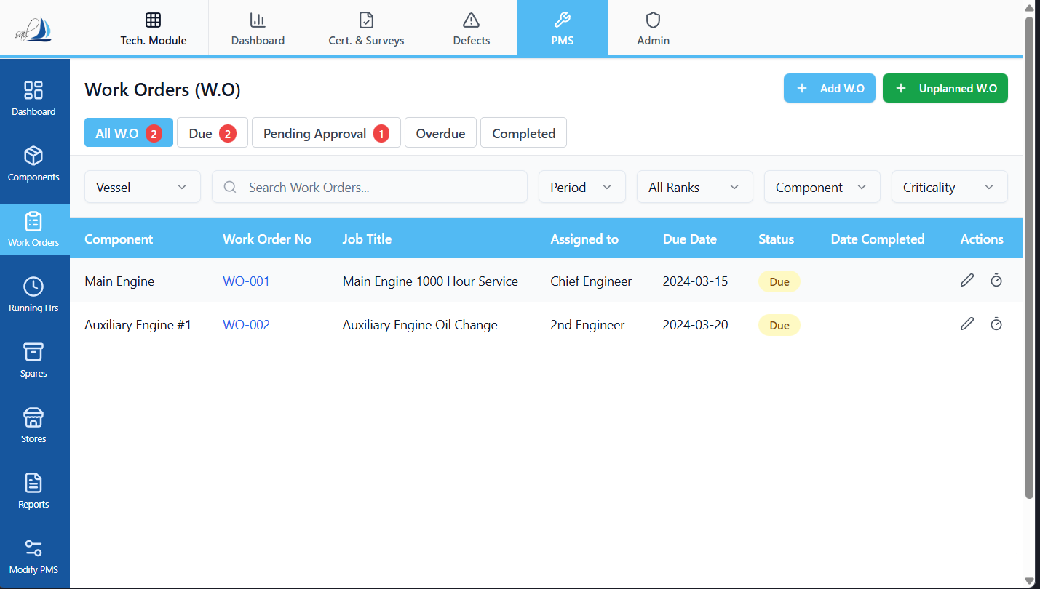

Ship side:
- Ship fills Part B.
- Clicks Submit.
- Status becomes Pending Approval.
- HoD (Engine/Deck)** receives WO for approval.
Ship cannot modify after submission (unless office rejects and reopens).
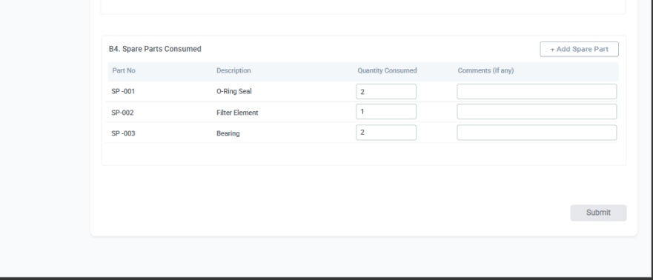

Office / HoD approval:

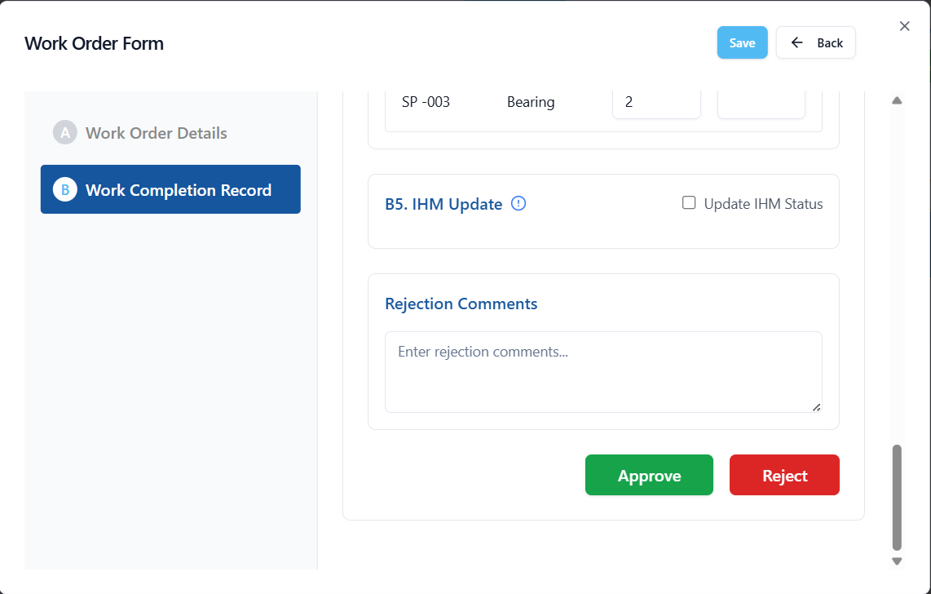
When HoD opens WO:
- Shows Part A (read-only)
- Shows Part B (review-only)
- Approve buttons:
  - Approve
  - Reject (send back to ship for correction)

Upon approval:
- Part A & Part B become permanently immutable.
- Work Order status → Completed.
- Maintenance History entry created.
- Components → Section C (Jobs):
  - Last Done Date updated
  - Last Done RH updated
  - Next Due recalculated
- Running Hours Module updated
- Spares inventory adjusted
- Any pending WO for the same job & cycle becomes:
  - “Superseded”
  - or cancelled (based on admin setting)

3.8 Part B Permissions Matrix
Action | Ship | Office/HoD | PMS Admin
Fill Part B | ✔️ | ✔️ (if reopening) | ✔️
Upload RA / Forms | ✔️ | ✔️ | ✔️
Edit after Submit | ❌ | ✔️ (Reopen option) | ✔️
Approve | ❌ | ✔️ (HoD only) | ✔️
Reject for Rework | ❌ | ✔️ | ✔️
View Completed WO | ✔️ | ✔️ | ✔️

3.9 Final Immutability
After approval:
- Part A & Part B are locked permanently.
- No user (including admin) can modify:
  - Running hours
  - Spare consumption
  - Safety checks
  - Work descriptions
  - Attachments
  - Spares deduction
  - Next Due logic
- WO becomes a legal record and class evidence.

SECTION 4 — WORK INSTRUCTIONS MODAL
(Standard Operating Procedures / Maker Manual Steps / Company Instructions)
This modal allows the office to insert step-by-step work instructions for the work order.
These instructions guide the ship staff while performing the job.
Ship can only view, not edit.

4.1 Purpose of Work Instructions
- Provide clear, structured, approved procedures for executing the job.
- Serve as SOP copied from:
  - Maker manuals
  - Company PMS procedures
  - Class/Flag circulars
  - Office instructions
- Ensure uniform maintenance execution across vessels.
- Allow office to update and standardize instructions quickly.

4.2 When the Modal Is Used

1. During WO Creation (Planned or Unplanned)
Office can:
- Add sections
- Add steps
- Paste text from manuals
- Format instructions

2. During WO Execution (Ship)
Ship opens the modal:
- For reference
- Instructions appear as read-only
- Useful for planned maintenance and breakdowns

3. After Completion & Approval
Remains permanently viewable as part of WO history.

4.3 How It Is Accessed
A Work Instructions button appears at the top of Part A (planned & unplanned):
[ Work Instructions ]
Clicking opens a large centered modal overlay.

4.4 Modal Layout & Elements

Header
- Title: “Work Instructions”
- Small subtext: “Add work instructions – Text or Copy Paste from Manuals”
- Close (X) button at top right

Content Area
A large text editor capable of:
- Paragraphs
- Numbered lists
- Bullet lists
- Bold / Italic
- Section headings
- Multi-section formatting (as per screenshot)
Example from your UI:
1. Section One

Follow below instruction when carrying out the task:
1. Step 1
2. Step 2
3. Step 3

2. Section Two
Follow below instruction when carrying out the task:
1. Step 1
2. Step 2
3. Step 3

Save Button
- Saves instructions to WO Part A.
- Works only for office.
- Ship does not see or use Save.

4.5 Data Storage Logic
Stored in work_order_instructions field under Work Order Part A.
Fields saved:
Field | Description
wo_id | Work Order ID
instructions_text | Full formatted text
created_by | User who added instructions
created_date | Timestamp
last_modified_by | For tracking edits
last_modified_date | Timestamp

4.6 Permissions
Role | View | Edit | Create
Ship | ✔️ View only | ❌ | ❌
Office / HoD | ✔️ | ✔️ Editable | ✔️
PMS Admin | ✔️ | ✔️ | ✔️
Notes:
- Ship never edits instructions.
- Once WO is approved, modal becomes 100% read-only.

4.7 Linking to Jobs
When WO is auto-generated from a Job:
- Work Instructions may also be inherited from Job Template (if you enable this later).
- Office can modify them per WO if required.
For On-Demand WO:
- Instructions still load from job template.
For Unplanned WO:
- Blank by default
- Ship still cannot edit
- Office can add instructions if needed

4.8 Immutability Rules
After WO approval:
- Work instructions are frozen permanently.
- No user—including PMS Admin—should modify them.
- They become part of legal maintenance evidence.

4.9 Relationship to Part A and Part B
- Work Instructions belong to Part A logically (job details).
- Ship uses them while filling Part B.
- They do not change job cycles or spares; they are purely procedural guidance.

4.10 Safety Integration
Safety requirements (PPE, permits) from Part A do not appear in this modal, but Work Instructions may reference safety steps.
Example:
- “Ensure Engine Room ventilation is running.”
- “Apply Lock-Out/Tag-Out on M/E FO valves before opening.”
This keeps it separate but complementary.

SECTION 5 — POSTPONE WORK ORDER MODAL
(Controlled postponement of a Work Order with full audit trail + new due date + office alerting)
The Postpone Work Order Modal is used when a job cannot be performed on or before the due date, but must be formally postponed to a later date without marking it as completed.
This ensures:
- Zero manipulation of job cycles
- Proper logged postponement
- Transparent auditability
- Automatic reappearance of WO when new date arrives
- Alerts for office

5.1 Purpose of Postponement
Postponement is used for scenarios such as:
- Vessel in a restricted port
- Transiting HRA (High Risk Area)
- Sailing during unfavourable weather
- Port operations preventing maintenance
- Unavailability of critical spares/tools
- Breakdown handling & workload management
Postponing is not equal to completing the job.
Instead:
- WO remains outstanding
- Due date moves to a new date
- History logs a postponement event
- WO reappears automatically when the postponed date arrives

5.2 Access Control
Role | Access | Notes
Ship User | ❌ No | Ship cannot postpone
Head of Department (CE/CO/Master) | ✔️ Yes | Authority defined by client
Office / Superintendent | ✔️ Yes | Additional oversight
PMS Admin | ✔️ Full | For testing and overrides
Only HoD + Office have authority.

5.3 How to Open the Modal
The modal can be triggered by:
- Clicking a Postpone icon on a WO row
- Opening the WO and clicking "Postpone Work Order" button (optional placement)
This opens a centered overlay modal.

5.4 Modal Layout (As per your screenshots)

Header
- Title: Postpone Work Order
- Close (X) button

Section 1 — Work Order Snapshot
Read-only fields:
- Work Order ID
- Component
- Job Title
- Assigned To
- Original Due Date
- Inform Office (checkbox)
Behavior:
- All fields are locked, read-only.
- “Inform Office” triggers an alert notification (details in Admin Alerts module).

5.5 Section 2 — Postponement Data (Editable)

1. Reason for Postponement
- Free-text textarea
- Mandatory for postponing
- Examples:
  - “Vessel entering ECA zone, cannot shut down generator.”
  - “Insufficient manpower; crane under breakdown.”
  - “Critical operations in progress.”

2. Authorized By
- Dropdown
- Values depend on department:
  - Engine: Chief Engineer
  - Deck: Chief Officer / Master
- This is configured by client’s superintendent.

3. Approval Remarks
- Optional notes
- For additional comments or justification

4. Next Due Date
- Calendar picker
- Mandatory
- Must be later than Original Due Date

5. Duration of Postponement
- Auto-calculated display:
- Duration = New Due Date – Original Due Date
- Read-only

6. Attach Document
- Optional file upload
- Examples:
  - Port restrictions notice
  - Safety circular
  - Email from office
  - Condition report
All files become read-only after approval.

5.6 Confirmation Buttons
- Confirm Postpone (action button)
- Cancel (close modal)

5.7 Backend Logic Upon Confirming Postpone
When HoD confirms postponement:

1. WO Status is updated to “Postponed”
- Replaces “Due”, “Due (Grace P)”, or “Overdue”
- Continues to appear in list but with blue “Postponed” badge

2. New Due Date replaces old
Stored in WO record
Old due date remains in history log

3. WO does NOT become Completed
It stays outstanding, just rescheduled.

4. WO will re-enter the Due/Due(Grace P)/Overdue cycle
When the new due date approaches:
- Within lead time → “Due”
- Passed due date → still outstanding
- Passed grace → “Overdue”

5. Maintenance History entry created
A new record is added:
[Postponed]
WO-2025-17
Original Due: 03-May-2025
New Due: 15-May-2025
Reason: Vessel in HRA.
Authorized By: Chief Engineer
Remarks: Await calm weather.
This is stored with history_type = POSTPONEMENT
Not counted as job completion.

6. Job Cycle is NOT reset
- Last Done Date stays unchanged
- Last Done RH stays unchanged
- Next Due = postponed date
- WO linked to this cycle stays active

7. Office Alert (if checkbox selected)
Triggers alert record in Admin → Alerts module:
- Vessel
- Component
- WO number
- New due date
- Reason for postponement
- Authorized by
- Alert type: “Work Order Postponed”
Office receives:
- Notification in alert panel
- Optional email (if configured later)

5.8 Validation Rules
Check | Validation
Reason empty | ❌ Block submission
Next Due Date earlier than original | ❌ Not allowed
Authorized By not selected | ❌ Block
Attachment optional | ✔ Allowed
Inform Office optional | ✔ Allowed

5.9 Immutability After Postponement
- All postponement fields become locked
- WO returns to editable state only when filling Part B (once user starts actual work)
- WO cannot be postponed again unless allowed by client rules (optional future feature)

5.10 Permissions Matrix (Postpone Feature)
Action | Ship | HoD | Office | PMS Admin
Open Postpone Modal | ❌ | ✔️ | ✔️ | ✔️
Fill Postponement Data | ❌ | ✔️ | ✔️ | ✔️
Change Due Date | ❌ | ✔️ | ✔️ | ✔️
Attach Document | ❌ | ✔️ | ✔️ | ✔️
Confirm Postpone | ❌ | ✔️ | ✔️ | ✔️
View Postponement History | ✔️ | ✔️ | ✔️ | ✔️

SECTION 6 — WORK ORDER STATUS & LIFECYCLE LOGIC
(Full system behavior of all WO states, transitions, triggers, and control logic)
A Work Order (WO) in PMS moves through clearly defined status stages.
These statuses drive visibility, filters, WO routing, audits, overdue logic, grace-period logic, and reporting.
Below is the complete lifecycle for both Planned and Unplanned Work Orders.

6.1 Status List (Final Canonical List)
These statuses exist in the PMS:

1. NOT GENERATED (Job only)
Job exists but WO not yet created (future triggered).

2. DUE
WO created within lead-time window but before due date.

3. DUE (Grace P)
WO is past due date but still within allowed grace period.

4. OVERDUE
WO is past both due date AND grace period.

5. POSTPONED
WO formally postponed with new next due date.

6. PENDING APPROVAL
Ship has filled Part B and submitted for approval.

7. COMPLETED
HoD has approved the WO; it is finalized and immutable.
(No “Rejected” status. Office rejection sends the WO back to ship in editable state with status = DUE or POSTPONED depending on cycle.)

6.2 Status Transition Diagram (Text Version)
[NOT GENERATED]
|
(WO auto-created based on lead time OR created manually)
↓
[DUE]
|
(past due date)
↓
[DUE (GRACE P)]
|
(past grace period)
↓
[OVERDUE]
|
(Postpone action)
↓
[POSTPONED]
|
(new postponed due date arrives)
↓
[DUE] again
|
(Ship fills Part B → submit)
↓
[PENDING APPROVAL]
|
(Approve)
↓
[COMPLETED]
This is the single authoritative lifecycle.

6.3 Status Descriptions & Rules

6.3.1 NOT GENERATED (Job Only)
A job exists in Components → Section C, but WO has not been created yet because:
- It’s not within lead-time
- Running hours are below trigger threshold
Status: job-level concept, not shown in WO list.

6.3.2 DUE
A Work Order becomes Due when:
- Today ≥ (Next Due Date – Lead Time)
- OR Running Hours ≥ (Trigger RH – Lead Time RH)
UI Behavior:
- Orange badge “Due”
Actions Allowed:
- Ship can fill Part B
- Ship cannot postpone
- HoD can postpone
- HoD cannot approve until Part B is filled

6.3.3 DUE (Grace P)
Occurs when:

For calendar-based jobs:
- Today > Due Date
- But still within “Grace Period” defined in Admin module:
  - End of the same month (primary rule)
  - If due in last 1 week → 7 days grace

For RH-based jobs:
- Current RH > Due RH
- But < (Due RH + 168 running hours)
UI Behavior:
- Yellow/Amber badge “Grace P”
Purpose:
- Practical buffer to avoid unnecessary escalation to office
- WO still counted as outstanding

6.3.4 OVERDUE
A WO becomes Overdue when:

Calendar Jobs:
- Today > Due Date + Grace Period

RH Jobs:
- Current RH > (Due RH + 168 hours)
UI Behavior:
- Red badge “Overdue”
Actions:
- Ship can fill Part B
- Ship cannot postpone
- HoD/Office can postpone
- Strongly recommended for ship to escalate conditions
Important:
Overdue WO counts as a high-risk audit item.

6.3.5 POSTPONED
After HoD postpones the WO:
- Status changes to POSTPONED (blue badge)
- WO remains outstanding
- New due date is stored
- Postponement entry added to job’s maintenance history
- WO will re-trigger as DUE when new lead-time window starts
Actions:
- Ship can fill Part B only when WO is DUE again
- Until then → no Part B editing allowed
- Postponed WO is NOT marked Completed

6.3.6 PENDING APPROVAL
Ship has filled Part B and submitted.
Actions:
- HoD reviews and approves or rejects
- Ship cannot edit
- Office can only approve or reject
UI Behavior:
- Grey/blue badge “Pending Approval”
- WO is no longer editable by ship

6.3.7 COMPLETED
Final, immutable state.
Occurs when:
- HoD approves the WO in Part B

Effects:
- Part A & B locked forever
- Entry created in Maintenance History section for that job
- Component Job → Last Done / Next Due updated
- Running Hours updated
- Spare consumption deducted
- All files attached in Part B remain permanent
- Any other WO auto-generated for the same job-cycle becomes superseded
UI Behavior:
- Green badge “Completed”

6.4 Status & Role Interaction Summary
Status | Ship | HoD/Office | PMS Admin
NOT GENERATED | – | – | –
DUE | Fill Part B | Postpone/Approve later | Full
Grace P | Fill Part B | Postpone | Full
Overdue | Fill Part B | Postpone | Full
Postponed | Cannot fill | Can un-postpone (revert) | Full
Pending Approval | View only | Approve/Reject | Full
Completed | View only | View only | View only

6.5 Lifecycle Rules for Planned vs Unplanned WO

6.5.1 Planned WO
- Auto-generated
- On-Demand (from job row)
- Manual (rare, office only)
Planned WO affects:
- Job cycle
- Last Done
- Next Due

6.5.2 Unplanned WO
- Ship creates manually via +Unplanned
- Does NOT automatically affect job cycle
- BUT if user links it to an existing job → it becomes a cycle reset
We already designed linking mechanism in the logic.

6.6 Important System Behaviors

6.6.1 Secondary WO Supersession
If an On-Demand WO or Manual WO is completed before the auto-generated planned WO:
- System closes or marks the auto-generated WO as:
  - “Superseded by Early WO”
  - Or removes it (based on admin setting)
This keeps job cycle clean.

6.6.2 Job Cycle Update Upon Completion
When WO is approved:
- If calendar job:
  - Last Done Date = Completion Date
  - Next Due = Last Done Date + Frequency
- If RH job:
  - Last Done RH = B3 Current RH
  - Next Due RH = Last Done RH + Frequency Hrs

6.6.3 Running Hours Propagation
On completion:
- Δ RH = Current – Previous
- Propagate Δ to all children in component tree
- Update parent and children RH
- Log RH update in RH-history table

6.6.4 Spare Consumption
When approved:
- Deduct consumption from inventory
- If less than zero:
  - Trigger critical inventory alert in Admin Alerts module

6.6.5 Postponement Loop
Once WO becomes postponed:
- WO waits silently
- Job cycle does NOT shift forward
- New lead-time will trigger WO again as DUE
- No limit on number of postponements (unless client wants limit)

6.7 Workflow Summary (Bird’s Eye View)

✔ Auto-Generate
Job says due – system creates WO → DUE

✔ Ship Executes
Ship does job → fills Part B → submits → PENDING APPROVAL

✔ HoD Approves
WO → COMPLETED
History updated
Next Due recalculated

✔ Postpone If Needed
If job cannot be done → Postpone modal → POSTPONED
WO reactivates later → DUE → PENDING APPROVAL → COMPLETED

SECTION 7 — WORK ORDER PERMISSIONS MODULE
(Role-Based Access Control for Work Order Creation, Editing, Approval & Viewing)
PMS uses a strict, predictable permission model to ensure:
- Class compliance
- Data integrity
- Protection of immutable maintenance records
- Separation of duties between ship and office
- Transparent audit trails
Roles differ per vessel department, but logically mapped as:
- Ship User (Assigned Crew / Engineer / Officer)
- Head of Department (HoD: CE/CO/Master)
- Shore Office (Superintendent / Technical Team)
- PMS Admin (Software Company / System Administrator)
Below is the FULL permission matrix covering Planned WO, Unplanned WO, Part A, Part B, Status transitions, postponement, and special functions.

7.1 High-Level Permission Principles
- Ship never edits Part A
- Ship only fills Part B
- HoD approves or rejects
- Office can create and modify WO before approval
- No user can change anything after approval
- PMS Admin has override access only for configuration—not for altering completed WOs
- All edits before approval are tracked
- All approvals create immutable records

7.2 Permission Categories
We divide permissions into:
- Work Order Creation (Planned + Unplanned)
- Work Order Editing (Part A + Part B)
- Work Order Approval / Rejection
- Postponement
- Viewing Work Orders
- Access to Work Order History
- Spare Consumption Rights
- Running Hours Update Rights
- Work Instructions Visibility / Editing

7.3 Work Order Creation Permissions

1. Planned Work Order (Auto-Generated)
Role | Can Trigger? | Notes
Ship | ❌ | System generates automatically
HoD | ❌ | Cannot manually trigger
Office | ❌ (auto only) | Can adjust generation rules via Admin
PMS Admin | ✔️ Can simulate | For testing only

2. Planned WO (Manual Creation via +Add W.O)
Role | Permission
Ship | ❌ No access
HoD | ❌ Not allowed
Office | ✔️ Can create manual planned WO
PMS Admin | ✔️ Full

3. On-Demand WO (from Components → Jobs)
Role | Permission
Ship | ✔️ Yes (via Create WO Now)
HoD | ✔️ Yes
Office | ✔️ Yes
PMS Admin | ✔️ Yes

4. Unplanned WO (Breakdown WO)
Role | Permission
Ship | ✔️ Yes
HoD | ✔️ Yes
Office | ✔️ Yes
PMS Admin | ✔️ Yes

7.4 Work Order Editing Permissions
We break into Part A and Part B.

7.4.1 Part A (Immutable Job Template Data)
Role | Edit? | Notes
Ship | ❌ Never | Job data must remain untouched
HoD | ❌ Not allowed | Only review
Office | ✔️ Only before initial save/creation | After creation → locked
PMS Admin | ✔️ Only for configuration | Not allowed after approval
Once WO exists, Part A becomes read-only for all ship users.
After approval → Part A becomes 100% immutable for everyone.

7.4.2 Part B (Execution & Completion Data)
Role | Edit? | Notes
Ship | ✔️ Until submit | After submission → locked
HoD | ✔️ Only when rejected back to ship; OR allowed by design | Typically not editing
Office | ✔️ If re-opened | Rarely used
PMS Admin | ✔️ Override | For correction (audit logged)
After approval → NO edits allowed by anyone.

7.5 Approval Permissions
Role | Approve? | Notes
Ship | ❌ Never | Ship only submits
HoD | ✔️ Primary approver | CE for engine, CO/Master for deck
Office | ✔️ Can approve if defined | Depends on client
PMS Admin | ✔️ Only for testing | Should not be used operationally
Approval is always one-level unless company workflow says otherwise.

7.6 Reject & Resubmit Permissions
If HoD rejects Part B:
- Status → DUE or POSTPONED (based on cycle)
- Ship gets editing rights back
- Part B becomes editable again
- Part A remains locked

7.7 Postponement Permissions
Role | Permission
Ship | ❌ Cannot postpone
HoD | ✔️ Can postpone
Office | ✔️ Can postpone
PMS Admin | ✔️ Full
Postponement is never allowed by ship.
All postponement actions are fully logged in Maintenance History.

7.8 Running Hours Permissions
Role | Enter RH? | Notes
Ship | ✔️ In Part B only | Updates component RH
HoD | ❌ | Only reviews
Office | ❌ | Not involved
PMS Admin | ✔️ Can correct | Logs delta

7.9 Spare Consumption Permissions
Role | Permission
Ship | ✔️ Enter consumption in Part B
HoD | ❌
Office | ❌
PMS Admin | ✔️ Override if required
After approval, inventory deduction occurs automatically.

7.10 Work Instructions Permissions
Role | View | Edit
Ship | ✔️ View Only | ❌
HoD | ✔️ View | ❌
Office | ✔️ View | ✔️ Edit
PMS Admin | ✔️ View | ✔️ Edit
After WO approval → instructions become locked forever.

7.11 Maintenance History Permissions
Role | View | Edit
Ship | ✔️ View all | ❌
HoD | ✔️ View all | ❌
Office | ✔️ View all | ❌
PMS Admin | ✔️ View all | ❌
No one can modify maintenance history.

7.12 Final Immutable Rules
Once WO is approved:
- Part A locked
- Part B locked
- Work Instructions locked
- Spare consumption locked
- RH locked
- Postponement history locked
- Job cycle updated
- Inventory updated
- WO becomes legal evidence
Even PMS Admin cannot modify Completed WOs.

SECTION 8 — WORK ORDER NUMBERING LOGIC & IDENTIFICATION STRUCTURE
Work Orders in PMS use a structured, meaningful, traceable numbering system.
The system ensures:
- Every WO is globally unique
- WO numbers link clearly back to the job
- On-demand WOs follow the same logic
- Unplanned WOs have a separate, recognizable series
- Sorting by WO number = sorting by time + job
- Multi-vessel PMS scalability
Below is the complete, final numbering logic.

8.1 NUMBERING FORMAT FOR PLANNED WOs
(Auto-generated + On-Demand + Manual Planned)
Planned WOs always reference a job, so the job code forms part of the WO number.

Final format:
<J0B CODE>.WO-<YEAR>-<RUNNING NUMBER>

Example:
J0B-331.831-02.WO-2025-01
Breakdown:
- J0B-331.831-02 → Job Code
- WO → Identifies Work Order
- 2025 → Year
- 01 → Incremental sequence for that job in that year
Every job has its own WO counter.

8.2 Work Order Counters (Per Job, Per Year)
Each job (example: J0B-331.831-02) has:
- Counter resets on 01 January every year
- Sequence increments every time a WO is created for that job
  - Auto-generated
  - On-demand
  - Manually created planned WO
Example:
WO-2025-01
WO-2025-02
WO-2025-03
This helps easily track:
- How many times a job was executed in the year
- WO frequency
- Maintenance patterns

8.3 Planned WO Types That Use This Format
WO Type | Includes Job Code | Format
Auto-generated Planned WO | ✔ Yes | Job.WO-YYYY-XX
On-Demand WO (from Components → Jobs) | ✔ Yes | Job.WO-YYYY-XX
Manual Planned WO | ✔ Yes | Job.WO-YYYY-XX
All planned WOs MUST use this format.

8.4 NUMBERING FORMAT FOR UNPLANNED WOs
Unplanned Work Orders are not linked to a job template.
They represent:
- Breakdown work
- One-time maintenance
- Emergency tasks
- Corrective actions
- Unexpected repairs
Therefore they need a separate universal series.

Final format:
UWO-<VESSEL CODE>-<YEAR>-<RUNNING NUMBER>

Example:
UWO-AEH-2025-03
Breakdown:
- UWO → Unplanned Work Order
- AEH → Vessel code (e.g., African Eagle / African Heron)
- 2025 → Year
- 03 → Sequence for that vessel in that year
Counters reset per vessel, every year.

8.5 Why Vessel Code Is Required in UWO
- Unplanned WOs are not tied to a job
- Many vessels share the same PMS backend
- Vessel code prevents collisions
- Facilitates reporting for fleets
- Allows office to quickly identify vessel of origin
- Class submissions require vessel identification in record ID

8.6 NUMBERING FORMAT FOR POSTPONEMENTS
Postponements do not get a new WO number.
They attach a postponement record to the same WO.
Format:
WO-XXXX-XX.POSTPONE-<YYYYMMDD>
This is an internal log entry, not shown as user-facing WO number.

8.7 NUMBERING FORMAT FOR MAINTENANCE HISTORY RECORDS
Each WO completion creates one Maintenance History entry:
MHR-<WO NUMBER>-<SEQUENCE>
Normally sequence = 01 (because one entry per WO).

8.8 NUMBERING FORMAT FOR SPARE CONSUMPTION RECORDS
When a WO uses spares:
SCR-<WO NUMBER>-<LINE NUMBER>
Example:
SCR-J0B-331.831-02.WO-2025-01-01
Meaning:
- From WO #1
- First spare consumption entry

8.9 Validations in Number Generation
- WO numbers must be unique
- WO cannot be recreated using same job-cycle
- Counters auto-increment with no gaps
- Counters reset yearly
- Unplanned WO must always start with UWO-
- Planned WO must always start with JobCode.WO-

8.10 Where WO Number is Displayed
- WO List (main screen)
- WO Form Part A
- WO Form Part B
- Maintenance History
- Spares Log
- Running Hours Log
- Component → Jobs → History
- Reports Module
- PDF exports
- Office dashboard
This creates complete traceability across modules.

8.11 Backend Storage Fields
Field | Description
wo_number | Full WO number string
wo_short | Optional short internal ID
job_code | Linked job code (NULL for unplanned)
is_unplanned | True/False
vessel_code | For UWO
sequence_number | Running sequence
year | For versioning & resets
All fields are indexed for fast search.

8.12 Rules for Editing WO Number
No user (including PMS Admin) may edit WO number, ever.
Only system generates WO numbers.

SECTION 9 — WORK ORDER LIST SORTING, FILTERING & SEARCH LOGIC
(How Work Orders appear, in what order, and how the user can filter & search them)
The WO Dashboard is the primary operational screen, so sorting and filtering must be:
- fast
- predictable
- intuitive for ship & office
- optimized for overdue visibility
- consistent across departments
- scalable for large fleets
Below is the complete logic.

9.1 DEFAULT SORT ORDER (MOST IMPORTANT RULE)
When the WO list loads (or after clearing all filters):

Sort Order Priority (Descending Importance):
- Overdue WOs first
- Grace Period WOs second
- Due WOs third
- Postponed WOs fourth
- Pending Approval fifth
- Completed WOs last
Within each status group:
- Sort by Due Date (nearest first)
- If Due Date not applicable (RH jobs), sort by Remaining RH
- If equal → sort by Work Order No (newest first)

Example default ordering:
1. Overdue
2. Due (Grace P)
3. Due
4. Postponed
5. Pending Approval
6. Completed
This ensures:
- At-a-glance risk visibility
- Works across both engine & deck maintenance
- Matches superintendent & auditor expectations

9.2 STATUS FILTER TABS
At the top of the dashboard:

Tabs:
- All W.O
- Due
- Pending Approval
- Overdue
- Completed

Behavior:
- Clicking a tab clears all other filters (except vessel).
- Tab applies status filter:
  - Due = Due + Grace P
  - Overdue = only Overdue
  - Completed = only Completed
- Color badges reflect active count dynamically.
Examples:
- “Overdue (7)” means 7 WOs in overdue state for selected vessel.

9.3 FILTER BAR LOGIC
The WO list has four key filters:
- Period Filter
- Rank Filter (Assigned To)
- Component Filter
- Criticality Filter
These filters can be applied in combination, with the following behavior:

1. Period Filter
Options:
- Today
- This Week
- This Month
- Next 7 Days
- Next 30 Days
- Custom Range
- All Periods

Applied on:
- Due Date for calendar jobs
- Remaining RH + predicted date for RH-based jobs
- If RH-based job has no date prediction → not filtered out when using date ranges unless status is Completed.

2. Rank Filter (“Assigned To”)
List generated from the vessel’s rank master.
Selecting a rank shows WOs where:
- Assigned To = selected rank
Multiple selection optional (your choice later).

3. Component Filter
Dropdown showing full component list (SFI tree flattened).
Selecting component shows WOs where:
- WO.component_code = selected component
- Includes WOs created from jobs under this component
- Unplanned WOs also filtered by selected component

4. Criticality Filter
Options:
- All
- Critical Only
Critical Only → shows WOs for components where:
- component.is_critical = TRUE

9.4 SEARCH LOGIC (SMART SEARCH)
Search bar filters WOs in real time using fuzzy-matching on:
- Work Order No
- Job Title
- Component Name
- Component Code (SFI code)
- Assigned Rank
- Work Instructions text (optional, configurable)
- Part B text (optional, configurable)
- Spare Part No (optional)

Search is:
- Case-insensitive
- Space-insensitive
- Supports partial matching
- Prioritizes WO number > job title > component name

Examples:
User types: crane
→ Loads all crane-related components + jobs + WOs
User types: wo-2025-01
→ Loads that exact WO
User types: J0B-331
→ Filters all WOs linked to SFI 331 jobs

9.5 COMBINED FILTER LOGIC
Filters stack using AND logic:
(status match) AND (period match) AND (rank match) AND (component match) AND (critical match) AND (search match)
Exception:
- Search overrides period filter when searching WO number or component names directly.
- Status tabs override all filters except vessel.

9.6 BADGE & COLOR LOGIC

Status badges:
Status | Color
Completed | Green
Due | Orange
Grace P | Amber / Yellow
Overdue | Red
Postponed | Blue
Pending Approval | Grey / Blue
Badge color always reflects most up-to-date system state.

9.7 LIST REFRESH & REAL-TIME UPDATES
List refreshes automatically when:
- Ship submits Part B
- HoD approves
- HoD postpones
- Running hours module updates (for RH jobs)
- Lead time window triggered
- Due date passed
- Spare consumption recalculation
- Job cycle updates
Refresh triggers:
- Badge color updates
- WO repositioning via sorting
- Status label change

9.8 COLUMN SORTING (Optional Enhancement)
Manual sorting columns:
Column | Sort Type
Component | A–Z / Z–A
WO No | Ascending / Descending
Job Title | A–Z / Z–A
Assigned To | Rank hierarchy
Due Date | Earliest first
Date Completed | Recent first
Default sorting always overrides until user manually sorts.

9.9 EMPTY-STATE BEHAVIOR
If no Work Orders match the filters:

Show:
- A clean empty-state icon
- Text:
- No Work Orders found for the selected filters.
- A “Clear Filters” button
- A button to Create Unplanned WO (if user has permission)

9.10 MULTI-VESSEL SUPPORT
When vessel is changed:
- All filters reset (except global defaults)
- WO list reloads
- Component list reloads
- Rank list reloads
- Criticality indicator reloads
- RH predictions recalc

9.11 SYSTEM PERFORMANCE RULES
To support large lists:
- Pagination or infinite scroll for >300 WOs
- Server-side filtering + search
- Client-side caching of ranks and components
- Lazy-loading for large tables

Understood — I am ignoring the “uploaded file” system message again exactly as instructed.
Proceeding with SECTION 10 — WORK ORDER BACKEND LOGIC & DATA FLOW, written at the same level of detail and developer-readiness as previous sections.
This section explains how the Work Order module works internally:
- Database links
- Triggers
- Field updates
- Status transitions
- RH → Component updates
- Spares → Inventory updates
- History creation
- WO supersession logic
This is the “engine room” of PMS backend.

SECTION 10 — WORK ORDER BACKEND LOGIC & DATA FLOW
This section defines how the PMS backend generates, updates, links, and finalizes Work Orders.
It ensures 100% consistency between:
- Components Module
- Jobs Module
- Running Hours Module
- Inventory Module
- Alerts Module
- Work Orders Module
- Reports Module

10.1 DATA MODEL OVERVIEW
Work Orders are linked to:

1. Vessel Table
- vessel_code
- vessel_name

2. Component Table
- component_code
- component_name
- sfi_code

3. Job Table
- job_id
- component_code
- job_title
- frequency_type (Calendar/RH)
- frequency_value
- last_done_date
- last_done_rh
- next_due_date
- next_due_rh
- lead_time_days
- lead_time_rh

4. Work Order Table
- wo_id
- wo_number
- job_id (NULL for unplanned)
- component_code
- vessel_code
- assigned_rank
- approver_rank
- status
- due_date
- due_rh
- postponed_date
- created_from_job (T/F)
- creation_mode (AUTO / ON_DEMAND / MANUAL / UNPLANNED)

5. Work Instructions Table
- wo_id
- instructions_text

6. Work Completion (Part B) Table
- wo_id
- start_date
- start_time
- completion_date
- completion_time
- work_description
- experience_notes
- team_count
- total_time
- manhours
- performed_by
- current_rh

7. Work Order Spares Table
- wo_id
- spare_id
- quantity_consumed

8. Maintenance History Table
- history_id
- wo_number
- job_id
- component_code
- type (COMPLETED / POSTPONE)
- date
- details_json

9. Alerts Table
- alert_id
- vessel_code
- alert_type
- message
- timestamp
All tables referenced through foreign keys where appropriate.

10.2 AUTO-GENERATION OF PLANNED WORK ORDERS
The backend runs a scheduler that checks:

Calendar-based jobs:
IF TODAY >= (next_due_date - lead_time_days) THEN:
CREATE WO (Planned, Auto)

RH-based jobs:
IF CURRENT_RH >= (next_due_rh - lead_time_rh) THEN:
CREATE WO (Planned, Auto)

WO creation steps:
- Generate WO number using Section 8 rules
- Copy job template fields into Work Order Part A
- Copy spares, tools, safety requirements
- Insert WO into database
- Status = “Due”
- Alert created if configured

10.3 ON-DEMAND WO CREATION (FROM JOB ROW)
Triggered when user clicks Create WO Now.

Backend logic:
- Set created_from_job = TRUE
- Set creation_mode = 'ON_DEMAND'
- Pre-fill all job fields
- Generate WO number for job
- Status = “Due”
This allows early execution without breaking job cycles.

10.4 UNPLANNED WO CREATION
Triggered by +Unplanned WO.

Backend logic:
- Set job_id = NULL
- Set creation_mode = 'UNPLANNED'
- Generate WO ID using UWO format
- Component Code selected manually
- Default status = “Due”
Unplanned WO does not update job cycle unless linked to job manually (optional future feature).

10.5 STATUS ENGINE (AUTO TRANSITIONS)
System checks daily:

1. Due Calculation
IF TODAY < DUE_DATE AND WITHIN LEAD TIME → DUE

2. Grace Period
IF TODAY > DUE_DATE AND TODAY <= DUE_DATE + GRACE → GRACE P

3. Overdue
IF TODAY > DUE_DATE + GRACE → OVERDUE

4. RH-based logic
Similar evaluation using RH thresholds.

5. Supersession
If On-Demand WO is completed earlier:
MARK scheduled WO as SUPERSEDED

10.6 POSTPONEMENT ENGINE
When HoD postpones WO:

Backend steps:
- Move WO.status → POSTPONED
- Store:
  - old due date
  - new due date
  - reason
  - authorized by
- Insert POSTPONE record into Maintenance History
- If “Inform Office” → insert alert
- WO remains outstanding
- New due date controls future DUE → GRACE → OVERDUE logic

Important:
Job cycle does NOT update from postponement.

10.7 PART B SUBMISSION FLOW (SHIP SIDE)
Ship fills Part B and presses Submit.
Backend:
- Validate required fields (current RH, start/end times, reason if needed)
- Save all Part B data
- Lock Part B
- Update WO.status → PENDING APPROVAL
- Notify HoD (alert or in upcoming Alerts module)

10.8 APPROVAL ENGINE (HoD / Office)
When HoD approves:

Backend actions:
- Change status → COMPLETED
- Update job cycle (only if planned or linked):
  - last_done_date = completion_date
  - last_done_rh = B3.current_rh
  - next_due_date = last_done_date + frequency
  - next_due_rh = last_done_rh + frequency_rh
- Insert Maintenance History entry (COMPLETED)
- Deduct spare consumption real-time from Inventory module
- Update Running Hours module:
  - Δrh = B3.current_rh – previous rh
  - Δrh applied to children in component tree
- Close or supersede any older WO for the same job-cycle
- Log approval in audit table
- Lock ALL WO fields permanently

10.9 REJECT LOGIC
When HoD rejects Part B:

Steps:
- WO.status → revert to previous (DUE or POSTPONED)
- Part B becomes editable again
- Log rejection in audit table

10.10 SPARE CONSUMPTION DATA FLOW
When B4 is filled:
- Saved as temporary data until approval
- After approval:
  - Deduct from inventory
  - If spare becomes zero or below threshold → generate alert
  - Insert spare consumption record SCR

10.11 RUNNING HOURS DATA FLOW
On completion approval:
- Store B3.current_rh
- Calculate ΔRH
- Update parent component RH
- Update all child components RH
- Insert record into RH history
- Re-evaluate RH-based WOs for potential immediate Due/Grace/Overdue states

10.12 MAINTENANCE HISTORY DATA FLOW
Every completed WO or postponement inserts a history entry:
Fields:
- WO number
- Job ID
- Component Code
- Action Type (Completed / Postponed)
- Date
- Details (JSON: description, RH, time, spares etc.)
History is immutable.

10.13 ALERTS DATA FLOW
Alerts are triggered for:
- Postponement
- Overdue WO
- Grace Period WO
- Low stock after WO consumption
- Critical WO pending
Data stored in Alerts module (designed later).

10.14 DATA VALIDATIONS
Backend must validate:
- Start < End date
- RH not decreasing
- RH not jumping unrealistically (admin rule)
- Mandatory Part B fields
- Postpone new due date > old due date
- WO not already Completed

SECTION 11 — WORK ORDER REPORTING & ANALYTICS DATA POINTS
(All metrics, KPIs, fields, and derived values needed for reporting)
Work Orders are central to PMS reporting.
Reports require:
- Raw WO data
- Job-cycle data
- Running-hour impact data
- Spare usage data
- Trends & patterns
- Vessel-level KPIs
- Superintendent / Office dashboards
- Class / PSC-ready summaries
Below is the complete and final data set.

11.1 CORE WORK ORDER DATA POINTS

A. Work Order Identification
- WO Number
- WO ID
- Job ID (NULL for unplanned)
- Component Code
- Component Name
- Vessel Code
- Vessel Name
- Department (Deck / Engine / Electrical)
- Created From Job? (Yes/No)
- Creation Mode (Auto / On-Demand / Manual / Unplanned)

B. Status Data
- WO Status (Due / Grace P / Overdue / Postponed / Pending Approval / Completed)
- Status Change Dates
- Overdue Duration (days/hours)
- Grace Period Duration (days/hours)
- Postponement Count (number of times postponed)
- Number of Rejections (optional)

C. Scheduling Data
- Frequency Type (Calendar / RH)
- Frequency Value
- Last Done Date (job level)
- Last Done RH (job level)
- Next Due Date
- Next Due RH
- Lead Time (days / RH)
- Trigger Type (Date-triggered / RH-triggered)

D. Due Metrics
- Original Due Date
- New Due Date (if postponed)
- Days until Due (future)
- Days past Due (overdue)
- Days in Grace Period
- Days postponed
- Projected Next WO Date (based on current RH/date trends)

11.2 PART A DATA POINTS (JOB TEMPLATE FIELDS)

A. Job-Linked Data
- Job Title
- Job Category (Mechanical/Electrical/etc.)
- Job Priority
- Maintenance Type (Scheduled/Unplanned)
- Class Related (Yes/No)
- Safety Requirements (PPE, Permits)
- Procedure Revision No. (optional future field)

B. Assignment Data
- Assigned Rank
- Approver Rank
- Assigned Date
- WO Creation Date
- WO Created By System/User

11.3 PART B DATA POINTS (EXECUTION FIELDS)

A. Execution Data
- Start Date & Time
- Completion Date & Time
- Total Duration (Hrs)
- Number of Persons in Team
- Manhours
- Performed By Rank
- Assigned To Rank
- Remarks by Ship
- Job Experience Notes

B. Running Hours Data
- RH Before
- RH After
- Change in RH (ΔRH)
- Updated RH for Component
- Updated RH for Child Components
- Updated RH for Parent Component (if applicable)

11.4 SAFETY & COMPLIANCE DATA

A. Risk Assessment & Safety Documentation
- RA Completed (Yes/No/NA)
- Safety Checklist Completed (Yes/No/NA)
- Operational Forms Completed (Yes/No/NA)
- Uploaded Files:
  - RA document
  - Safety checklists
  - Operational forms
- File upload timestamp
- File uploaded by whom

B. Permit Data
- Hot Work Permit (if required)
- Enclosed Space Entry permit (if required)
- Other specific permits

C. Class / Regulatory Data
- Class related?
- Survey linkage (optional)
- Evidence documents (if uploaded)

11.5 SPARE PARTS CONSUMPTION DATA

A. Spare Usage
- Spare Code
- Spare Description
- Unit
- Quantity Consumed
- Expense Category (optional future field)
- ROB Before WO
- ROB After WO
- Inventory Alert Triggered? (Yes/No)

B. Spare Linkage
- Was spare linked from job template? (Yes/No)
- Was spare added manually? (Yes/No)

C. Inventory Integration
- Spare deduction timestamp
- Inventory transaction ID
- Who consumed the spare (Rank)

11.6 POSTPONEMENT DATA

A. Postpone Record Fields
- Postpone Status (Yes/No)
- Postpone Reason
- Postpone Authorized By
- Postpone Approved By
- Old Due Date
- New Due Date
- Duration Postponed (days)
- Attachments
- Postponement Timestamp
- “Inform Office” selected? (Yes/No)

B. Postponement KPI Fields
- No. of Times Job Was Postponed
- Total Postponed Days in Year
- Average Postponement Per Component
- Department-wise delays (Deck/Engine)

11.7 WORK ORDER CYCLE & JOB PERFORMANCE ANALYTICS

A. Cycle Compliance
- % WOs completed before due
- % WOs completed within grace
- % WOs overdue
- No. of overdue jobs per month
- Overdue duration (avg/max)

B. Job Completion Patterns
- Average completion time per job
- Jobs frequently postponed
- Jobs with highest spare usage
- Jobs consistently overdue
- Jobs rarely triggered (low RH usage)

C. Component-Based Analytics
- Components with most WOs
- Components with highest RH variation
- Components with highest downtime
- Critical components overdue count
- Critical WO compliance %

11.8 VESSEL/DEPARTMENT-WISE ANALYTICS

A. Engine Department KPIs
- Generator hours-related tasks due/overdue
- Machinery frequently undergoing RH tasks
- Top overdue engine jobs

B. Deck Department KPIs
- Crane/Winch maintenance compliance
- Navigation equipment WOs
- Lifesaving equipment maintenance patterns

C. Electrical Department KPIs
- Lighting/electrical WOs
- High-frequency electrical tasks
- Alarm-related jobs

11.9 FLEET LEVEL ANALYTICS
For shore office:
- Vessel maintenance health score
- Vessel overdue percentage
- Fleetwide average RH per day
- Fleetwide job compliance comparison
- Highest Maintenance Burden Components
- Breakdown WO frequency
- Spare consumption cost per vessel
- Vessel maintenance ranking system (optional)

11.10 SFI-BASED ANALYTICS
Using Components → SFI codes:
- WO count by SFI group
- RH distribution across SFI 3xx machinery
- SFI 4xx jobs vs calendar distribution
- Breakdown events per SFI code
- Highest frequency SFI sub-group WOs

11.11 REPORTS SUPPORTED BY THESE DATA POINTS
These data points power:
- WO Status Reports
- Pending Approval Reports
- Job Cycle Compliance Reports
- Component Maintenance History Reports
- RH-Based Trigger History Reports
- Spare Consumption Reports
- Postponement Reports
- Critical WO Summary
- Fleet Maintenance Scorecard
- Vessel Performance Summary
- Office Dashboard (Mouse-over metrics)
- Class Submission Reports

SECTION 12 — WORK ORDER LINKAGES WITH COMPONENTS, JOBS, INVENTORY & ALERTS MODULES
(Complete Inter-Module Integration Map)
Work Orders do NOT work in isolation. They are the core of PMS and require precise integration with the surrounding modules to maintain:
- Job cycles
- Component hierarchy
- Running hours
- Spare inventory
- Alerts & notifications
- Audit logs
- Reporting consistency
- Vessel-specific crew workflows
Below is the COMPLETE integration logic.

12.1 LINKAGE WITH COMPONENTS MODULE
(Components → Jobs → WO → History → Components)
Work Orders rely on the Components module for:

A. Component Identity
- WO must always be linked to a component_code
- This comes directly from the Components tree (SFI-based)

B. Parent–Child Hierarchy
WO execution affects:
- Parent RH
- Child RH
- Component grouping in WO list
- Component-level maintenance history

C. Create WO Now Button
Section C → Jobs → Actions → Create WO Now triggers:
- Planned WO creation
- Auto filling of Part A
- Correct linking to component & job
- Correct cycle update after completion

D. Maintenance History Written Back
After WO completion:
- Maintenance history is written back to the component’s history section
- This ensures:
  - Traceability
  - Component lifecycle tracking
  - Class compliance

12.2 LINKAGE WITH JOBS MODULE
(Jobs are templates; WOs are executions)
Jobs Module feeds WO module with:

A. Job Template Data → WO Part A
Including:
- Job Title
- Maintenance Type
- Frequency (Calendar/RH)
- Safety requirements
- Required spares & tools
- Job category
- Priority
- Class-related flag
- Work instructions (if stored at job level)

B. WO Auto-Generation Logic
Jobs determine:
- When WOs are auto-created
- Whether based on date or running hours
- Lead time settings
- Frequency values

C. Cycle Reset Logic
After WO completion:
- last_done_date updated
- last_done_rh updated
- next_due_date recalculated
- next_due_rh recalculated

D. Multiple WOs for Same Job
System ensures:
- On-demand WO supersedes auto-generated WO
- No double execution of same cycle

12.3 LINKAGE WITH RUNNING HOURS MODULE

A. RH Display in WO
Part B shows:
- Previous RH
- Current RH (entered by ship)

B. RH Update After Completion
Upon approval:
- Parent component RH = Current RH
- Children RH = Children RH + Δ (as per your rule)
- RH history updated
- Jobs next due RH recalculated

C. RH-Based WO Trigger
Scheduler checks:
IF current_rh >= next_due_rh - lead_time_rh
→ Auto-create WO

D. RH-Based Grace Logic
Grace for RH jobs = 168 RH

12.4 LINKAGE WITH INVENTORY (SPARES) MODULE

A. Planned WO — Part A: Spares Preloaded
- Spares assigned to a job appear in Part A
- Shows real-time ROB (retrieved live from Inventory)

B. Part B — Spare Consumption
Ship enters:
- Quantity consumed
- Comments

C. On Approval → Inventory Update
System performs:
- Deduct consumption
- Update ROB
- Insert Inventory Transaction Record
- Trigger alert if below reorder level

D. Auto-Generated Spare Codes
When adding new spare in Part B:
- System auto-generates next spare code
- Applies vessel-level master spare list logic

12.5 LINKAGE WITH TOOLS & EQUIPMENT MODULE (IF ENABLED)
Tools stored at job template are shown in WO Part A.
Later integration may allow:
- Tool inventory
- Tool maintenance tracking
- Calibration tracking
Placeholder structure exists.

12.6 LINKAGE WITH ALERTS MODULE
Alerts triggered by WO module feed into the Alerts dashboard.

A. Alert Types from WO
- Work Order Overdue
- Work Order Grace Period
- Postponed WO (Inform Office = Yes)
- Critical WO Pending
- Spare Stock Critical After WO Completion
- Pending Approval Over X days
- WO completed but RH abnormal (future)

B. Alert Data Fields
- Vessel Code
- Component Code
- WO Number
- Status
- Message
- Date & Time
- Severity (Low/Medium/High/Critical)

C. Trigger Moments
- At overdue transition
- At grace-period transition
- On postponement
- On WO approval (spare stock checks)
- On WO stuck in Pending Approval too long

12.7 LINKAGE WITH REPORTS MODULE
The WO module feeds data into these reports:

A. Maintenance History Report
- Per job
- Per component
- Per month
- Per vessel

B. Running Hours Log Report
- WO-driven RH updates
- Cycle resets

C. Spare Consumption Report
- WO-level usage
- ROB trends
- Reorder triggers

D. WO Completion Compliance
- Due vs Completed
- Overdue counts
- Grace usage

E. KPI Reports
- WO average duration
- WO delays
- WO refusal/rejection count
- WO quality and completeness

F. Fleet Level Summary
- Vessel compliance ranking
- Critical WO backlog
- Breakdown trend
- Engine vs Deck maintenance performance

12.8 LINKAGE WITH ADMIN MODULE
Admin module defines:

A. Lead Time Settings
- Per job frequency
- Per vessel defaults

B. Grace Period Settings
- For calendar jobs
- For RH jobs

C. Role-based Access
- Who can postpone
- Who approves
- Who creates WOs

D. Notification Settings
- Email recipients
- Push alerts
- Office escalation

E. Spare reorder threshold master
- Inventory alerts depend on these
- WO completion triggers check

12.9 LINKAGE WITH SECURITY & AUDIT MODULE
Every action is logged:

Tracked Events:
- WO creation (auto/manual/on-demand)
- WO submission (Part B)
- WO approval
- WO rejection
- WO postponement
- Spare consumption
- RH update
- Changes to Part A (office only before approval)
- Changes to Part B (ship before submission)
- Viewing records (optional, for full audit)
Stored in:
- audit_log
- maintenance_history
- rh_history

12.10 LINKAGE WITH COMPONENT TREE
Work Order path:
Component → Jobs (Section C) → WO → History → Component
- Component selection influences WO
- WO completion updates component-level history
- Navigation always returns user to component root
- Component filtering in WO list uses component_code

12.11 LINKAGE WITH MULTI-VESSEL DATABASE
WO table is scoped by vessel_code.
Changing vessel:
- Reloads WOs
- Reloads component list
- Reloads rank list
- Reloads criticality data
Work Orders NEVER cross vessels.

SECTION 13 — WORK ORDER MODULE: FINAL DEVELOPER NOTES, EDGE CASES & SYSTEM CONSTRAINTS
This section describes all critical development notes that MUST be followed to avoid breaking job cycles, inventory integrity, and RH-based calculations.
These rules override any default coding behavior.

13.1 GENERAL DEVELOPMENT PRINCIPLES
- Never allow modification of approved WOs
  - Approved WOs are treated as class and legal evidence.
  - Any modification is forbidden, even by PMS Admin.
- Part A must never be editable by ship users
  - Zero exceptions.
- Part B must lock automatically after submission
  - Only HoD can reopen by rejection.
- Spare consumption must NEVER be deducted before approval
  - Deduction occurs only after WO is approved.
- Running Hours must NEVER update before approval
  - Only after approval ensure RH propagation occurs.
- Postponement must never affect job cycle
  - Only changes due-date for the WO, not last-done.
- Unplanned WOs must NEVER accidentally reset job cycle
  - Only if “Link to Job” logic is added later.
- Auto-generated WO must NEVER duplicate a cycle
  - Use JobID + year + cycle number to enforce uniqueness.

13.2 EDGE CASES (VERY IMPORTANT)

EC1. WO created but no RH entered by ship
- If ship leaves RH blank → reject submission
- WO cannot proceed to approval
- Protects job-cycle integrity.

EC2. RH decreases (human error)
- If current_rh < previous_rh → block submission
- Manual override allowed ONLY via admin rule, not default behavior.

EC3. RH jumps abnormally
- If ΔRH > threshold (admin-defined), warn user:
- "Running hours variation is too high. Please confirm."
- Ship must confirm & HoD must approve.

EC4. Spare consumption more than ROB
- Allow ship to enter, but:
  - Negative ROB triggers automatic Inventory Critical Alert.

EC5. WO submitted after due date but before grace period
- Status remains “Pending Approval”
- After approval, WO still resets cycle normally.

EC6. WO submitted during Grace P but approved after Grace P
- Approval date does NOT affect compliance calculation.
- Compliance based on due date vs completion date.

EC7. WO completed early
- Allowed via On-Demand WO creation.
- Auto-generated upcoming WO must be superseded.

EC8. WO created but job was deleted/modified in job template
- WO keeps a snapshot of job template inside Part A.
- WO must NOT break or change due to job deletion.

EC9. RH-based jobs without RH update
- WO cannot complete without current RH entry.
- Block approval until RH entered.

EC10. Multiple postponements
- Allowed.
- Must log EACH postponement separately in maintenance history.

EC11. Ship submits WO without uploading mandatory files
- Uploads are not mandatory.
- Submission must be allowed.
- No blocking.

EC12. “Inform Office” ticked but no network
- Alert must be queued
- Sync in next vessel-to-office sync cycle.

EC13. WO gets postponed AFTER ship filled Part B
- Not allowed.
- Once ship submits Part B, only HoD approval/rejection allowed.
- Postponement disabled.

EC14. WO temporarily overdue due to timezone differences
- System must use UTC internally, not vessel time.
- Display vessel local time but calculate using UTC.

EC15. WO created for Component whose RH is outdated
- Show warning on WO form:
- Running hours for this component appear outdated. Please update RH module.

13.3 DATA INTEGRITY RULES

Rule 1: No orphan WOs
Every WO must have:
- VesselCode
- ComponentCode
For planned WOs:
- Must also have JobID

Rule 2: No WO without Due Date or Due RH
At least one field must be populated.

Rule 3: No negative or null manhours
Manhours must be auto-calculated by:
team_count × total_time

Rule 4: Spare codes must always auto-generate
Even if spare was created manually inside WO.

Rule 5: No editable WO Number
System-generated only.

Rule 6: Child RH propagation must ALWAYS use delta
Never override child RH by parent RH directly.

13.4 PERFORMANCE & SCALABILITY NOTES
- Bulk WO queries must use indexed fields
  - vessel_code
  - status
  - due_date
  - job_id
  - component_code
- WO list will grow extremely large (over years)
  - Use pagination or infinite scroll.
- History tables will grow faster than WO tables
  - Must be indexed and partitioned per vessel per year.
- Alerts must be asynchronous
  - Do NOT block WO save/approval if alert service down.
- Use caching for frequently accessed fields
  - Component name
  - Rank list
  - Vessel name

13.5 USER EXPERIENCE CONSTRAINTS
- Zero pop-ups on WO list except actions
- WO form must autosave Part B every X minutes
- Warnings must never block user unless critical
- Postponement modal must not pre-fill new due date
- Ship must not ever see job frequency values as editable
- Completion must not allow future dates
- WO form must scroll smoothly on all devices

13.6 SECURITY & AUDIT CONSTRAINTS

All actions must have:
- timestamp (UTC)
- vessel_time
- user_id
- device/browser data
- version number of PMS

Immutable data must be enforced at datasource level (database), NOT just UI
- Prevent data tampering
- Prevent database admin accidental changes

Every field modification BEFORE approval must be audit logged
- Old value
- New value
- User
- Time

13.7 SYSTEM RECOVERY & SYNC RULES (FOR OFFLINE SHIPS)
- If WO completed offline:
  - Queue WO completion
  - Sync once internet available
  - WO number must remain unchanged
- If two WO submissions conflict:
  - Server version overrides
  - Device version resyncs
- If RH updated offline:
  - RH delta applied only after sync
  - WO next due recalculated server-side
- Spare deduction offline:
  - Deduct after sync
  - If ROB goes negative during sync → alert immediately

13.8 CRITICAL EVENT FALLBACK LOGIC
If WO approval fails (network/timeout):
- WO remains in Pending Approval
- Ship cannot edit
- HoD must retry approval
- System must not create duplicate history entries
If spares deduction fails:
- WO still approved
- Spare sync retried
- Deduction occurs on retry

13.9 FINAL DEVELOPER WARNINGS
These MUST be followed:

❗ NEVER allow Part A editing after creation

❗ NEVER allow Part B editing after approval

❗ NEVER auto-reset job cycle on unplanned WO

❗ NEVER allow RH update without validation

❗ NEVER allow WO number modification

❗ NEVER allow spare deduction before approval

❗ NEVER break component hierarchy integrity

❗ NEVER delete WOs (only mark superseded)
This preserves compliance with:
- Class
- ISM
- TMSA
- PSC inspections
- Internal audits

SECTION 14 — DATABASE STRUCTURE / FIELD MAPPING (WORK ORDER MODULE)
This section defines the logical database structure for the Work Orders module.
It is not tied to a specific SQL dialect, but gives a clear table + field + relationship map that backend devs must follow.
It uses the already-existing global tables:
- components
- component_jobs
- component_running_hours_log
- component_maintenance_history
- spares_master / inventory_stock / inventory_movements
- alerts
- audit_log
and adds Work-Order–specific tables.

14.1 Overview of Work Order–Related Tables
New / primary tables for this module:
- work_orders – Core WO record (Part A + scheduling/status basics)
- work_order_completion – Part B data (execution, RH, descriptions, time, manpower)
- work_order_instructions – Work Instructions modal text
- work_order_safety_docs – Uploaded RA/checklists/operational forms (Section B1)
- work_order_spares_consumed – Spare consumption lines (Section B4)
Plus reuse of:
- component_maintenance_history – to log COMLETED/POSTPONED history per job/component
- component_running_hours_log – for RH deltas on completion
- inventory_movements – for stock deduction
- alerts – for overdue, postponed, low stock, etc.
- audit_log – for all changes

14.2 work_orders (Core Work Order Header – Part A + Status)
Represents one Work Order, planned or unplanned.
Table: work_orders
Key fields:
- id – PK (internal ID)
- wo_number – Full WO number (e.g., J0B-331.831-02.WO-2025-01 or UWO-AEH-2025-03)
- vessel_code
- component_code – FK → components.component_code
- job_id – FK → component_jobs.id (NULL for unplanned)
- creation_mode – ENUM: AUTO, ON_DEMAND, MANUAL, UNPLANNED
- created_from_job – BOOLEAN
- is_unplanned – BOOLEAN
Part A snapshot fields (immutable once WO created):
- job_title
- maintenance_type (Scheduled / Unplanned)
- job_category
- job_priority
- class_related (Yes/No)
- frequency_type (CALENDAR / RH)
- frequency_value (numeric)
- frequency_unit (MONTHS / DAYS / HOURS)
- lead_time_days
- lead_time_rh
- brief_work_description
- default_ppe_requirements (text/tag)
- default_permit_requirements (text/tag)
- default_safety_requirements (text)
Assignment & workflow fields:
- assigned_rank – e.g., 2/E, 3/O
- approver_rank – e.g., CE, CO, Master
- status – ENUM: DUE, GRACE_P, OVERDUE, POSTPONED, PENDING_APPROVAL, COMPLETED
- due_date – for calendar jobs
- due_rh – for RH jobs
- original_due_date
- postponed_due_date – current postponed due date if any
- postponement_count – integer
- pending_approval_since – timestamp
Audit fields:
- created_by
- created_at
- updated_by
- updated_at
Relationships:
- 1 work_orders → 1 components (via component_code)
- 1 work_orders → 0/1 component_jobs (via job_id)
- 1 work_orders → 1 work_order_completion
- 1 work_orders → many work_order_safety_docs
- 1 work_orders → many work_order_spares_consumed
- 1 work_orders → 0/1 work_order_instructions
- 1 work_orders → many alerts
- 1 work_orders → many audit_log entries
- 1 work_orders → many component_maintenance_history entries (type COMPLETED/POSTPONEMENT)

14.3 work_order_completion (Part B – Execution Data)
Stores everything the ship fills in Part B after doing the job.
Table: work_order_completion
Key fields:
- id – PK
- wo_id – FK → work_orders.id (1:1)
Execution timing & manpower:
- start_date
- start_time
- completion_date
- completion_time
- team_count – No. of persons
- total_time_hours
- manhours
- assigned_rank_at_execution – snapshot
- performed_by_rank
Work description:
- work_carried_out – detailed description
- job_experience_notes – additional comments
Running hours (B3):
- previous_rh – snapshot at start
- current_rh – value entered by ship
- delta_rh – calculated (current – previous)
RA / checklist flags (B1):
- ra_completed – ENUM (YES/NO/NA)
- safety_checklist_completed – ENUM
- operational_forms_completed – ENUM
Approval info:
- submitted_by
- submitted_at
- approved_by
- approved_at
- rejected_by (if any)
- rejected_at
- rejection_reason (optional)

14.4 work_order_instructions (Work Instructions Modal)
Stores the text shown in the Work Instructions modal.
Table: work_order_instructions
Key fields:
- id
- wo_id – FK → work_orders.id
- instructions_text – full formatted text / HTML / rich text
- created_by
- created_at
- last_modified_by
- last_modified_at
After WO is approved, this record is treated as read-only.

14.5 work_order_safety_docs (RA / Checklists / Forms Uploads)
Stores RA, safety checklists, operational forms uploaded in B1.
Table: work_order_safety_docs
Key fields:
- id
- wo_id – FK → work_orders.id
- doc_type – ENUM: RA, SAFETY_CHECKLIST, OPERATIONAL_FORM
- file_name
- file_path or storage_url
- uploaded_by
- uploaded_at
- can_ship_view – BOOLEAN (Yes)
- can_ship_download – BOOLEAN (usually Yes for these docs)
- is_active
No edits after WO completion; record is immutable.

14.6 work_order_spares_consumed (Spare Consumption – B4)
One row per spare consumed for a WO.
Table: work_order_spares_consumed
Key fields:
- id
- wo_id – FK → work_orders.id
- vessel_code
- part_code – FK → spares_master.part_code
- description_snapshot – spare name at time of WO (for history)
- quantity_consumed
- comments
- created_by
- created_at
- inventory_movement_id – FK → inventory_movements.id (after approval)
On WO approval:
- inventory_movements entry created
- inventory_stock updated

14.7 Reused Global Tables (Impact of WO)
These tables are already part of PMS but Work Orders write into them:

14.7.1 component_maintenance_history
Used to store all maintenance events (COMPLETED and POSTPONED) per job/component.
Key fields (extended for WO integration):
- id
- vessel_code
- component_code
- job_id (nullable for unplanned)
- wo_id
- wo_number
- event_type – ENUM: COMPLETED, POSTPONED
- event_date
- event_details_json – includes:
  - completion summary / postpone reason
  - RH, manhours, etc.
- created_at
WO Module writes here:
- On completion → event_type = COMPLETED
- On postpone → event_type = POSTPONED

14.7.2 component_running_hours_log
RH change entries from Part B.
Fields relevant for WO:
- id
- vessel_code
- component_code
- wo_id
- previous_rh
- new_rh
- delta_rh
- updated_by
- updated_at
- source – e.g. WO_COMPLETION

14.7.3 inventory_movements
Records inventory changes.
For WO consumption:
- movement_id
- vessel_code
- part_code
- movement_type = ISSUE
- quantity = quantity_consumed
- source_type = WORK_ORDER
- source_id = wo_id
- movement_time

14.7.4 alerts
WO triggers alert entries:
- id
- vessel_code
- alert_type – WO_OVERDUE, WO_GRACE, WO_POSTPONED, LOW_STOCK_AFTER_WO, etc.
- wo_id
- wo_number
- component_code
- severity
- message
- created_at
- resolved_at (optional)

14.7.5 audit_log
Every critical change is logged:
Fields include:
- id
- timestamp
- user_id
- action_type – CREATE_WO, UPDATE_WO, SUBMIT_PART_B, APPROVE_WO, POSTPONE_WO
- entity_type – WORK_ORDER, WORK_ORDER_COMPLETION, WORK_ORDER_SPARE
- entity_id
- field_name
- old_value
- new_value
- source – WEB, SYNC, etc.

14.8 RELATIONSHIP SUMMARY (ER VIEW IN WORDS)
- One Work Order (work_orders)
→ has one Completion record (work_order_completion)
→ has zero or one Work Instructions (work_order_instructions)
→ has many Safety Docs (work_order_safety_docs)
→ has many Spare Consumption rows (work_order_spares_consumed)
→ maps to one Component (components)
→ optionally maps to one Job (component_jobs)
→ writes many RH log rows (component_running_hours_log)
→ writes many History rows (component_maintenance_history)
→ produces zero or many Inventory Movements (inventory_movements)
→ may create several Alerts (alerts)
→ has many Audit entries (audit_log)

